Comparison of doing muons through Geant4 vs MUSUN

Estimations of muon flux at 4850 ft Davis Cavern, Homestake Mine are conducted by several tools, such as MUSUN and Geant4 simulation code. Both of them are taking account the surface mountain profile then transfer the surface muons down to the underground cavern. Figure 1 shows the surface elevation map from satellite data which adopted by the Geant4 simulation.

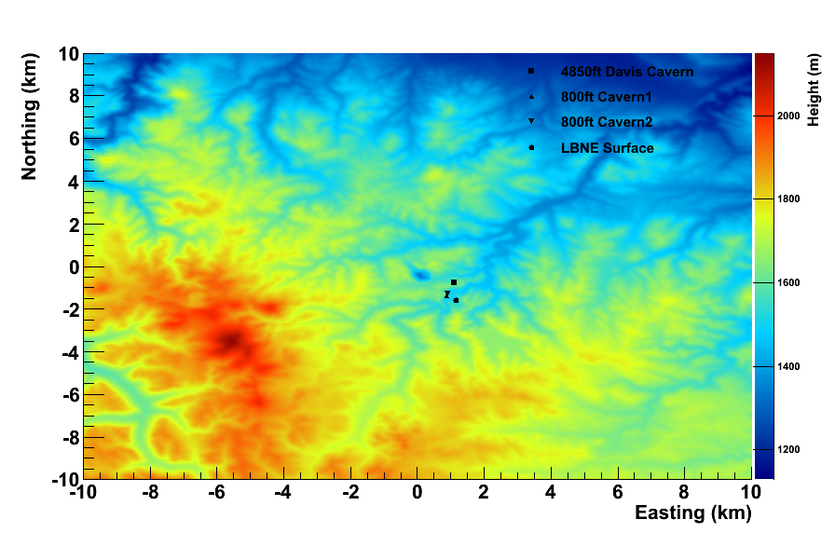

Figure 1. The surface mountain profile at Homestake Mine area from the satellite survey[1].

There are over 1400 meters of rock overburden for the Davis Cavern. The composition of the rock sampled from Homestake Mine are measured[2] and the sample 278-2[3] is adopted in the Geant4 simulation. The average rock density applied in Geant4 is 2.83 g/cm3 while 2.7 g/cm3 was taken by MUNSUN. The determination of the muons’ energy loss in the rocks is the key for the calculation.

By using Geant4, it tracks the muons step by step. All the processes of muons’ energy loss automatically registered and simulated by Geant4 itself. The interaction channels are validated as shown in Figure 2. It agrees with the PDG data pretty well.

Instead of track individual process, MUSUN calculate the energy loss and simulate the survival possibility for each muon. This way makes the processes simple and fast. However, only muons are taking cared and all the secondary particles generated in the rock are neglected.

The Figure 3 gives the comparison of energy distribution calculated using three different approaches – MUSUN, Geant4 and Mei & Hime prediction. The absolute flux calculated by them are 6.46e-9/cm2/s, 4.40e-9 /cm2/s and 4.36e-9 /cm2/s, respectively. The Figure 4 is the comparison of muon angular distribution obtained using MUSUN and Geant4 code, respectively.

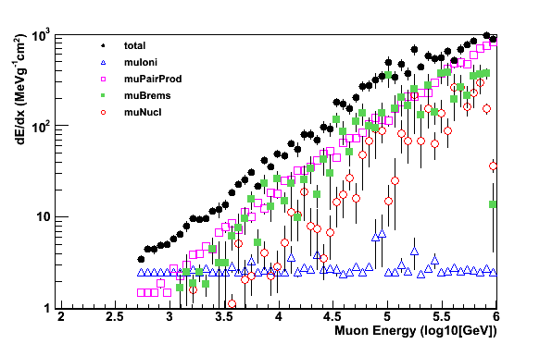

Figure 2. Muon energy loss by different interaction channels in Geant4.

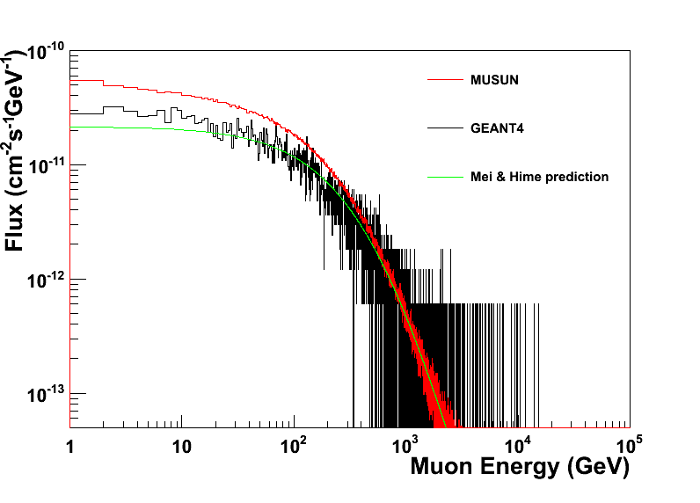

Figure 3. Muon energy spectrum at 4850 ft Davis Cavern estimated by MUSUN, GEANT4 and Mei&Hime prediction[4].

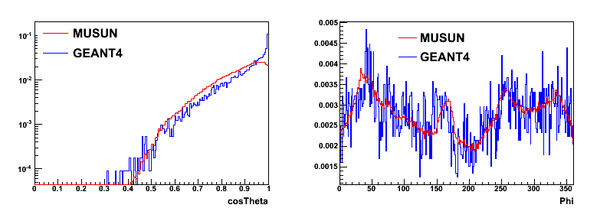

Figure 4. Comparison of muon angular distribution at 4850 ft Davis Cavern estimated by MUSUN and GEANT4.

[1] <http://eros.usgs.gov/>

[2] B.T. Jordan, Geochemistry tectonic setting of the Yates unit of the Poorman Formation (DUSEL bedrock) and other northern Black Hills amphibolites: geological Society of Americal Abstracts with Programs 41 (7) (2009) 271

[3] D.-M. Mei et al., Astroparticle physics 34(2010)33-39

[4] D.-M. Mei, A. Hime, Phys. Rev. D 73(2006)053004