** Chao writes:

**Summary of cosmic ray muon flux measurement at SURF**

The differential muon flux at 4850 ft (4.4 km.w.e) level at Homestake was measured by Cherry et al.[1] at early 80s. In order to characterize the muon flux as function of depth, the cosmic ray muon flux was measured in different depth of Homestake Mine by using plastic scintillation counters[2]. The muon detector consists of four fast plastic scintillation counters, each a square with a side length of 30.5 cm. The distance from the top to the bottom counter is 64.0 cm. The surface, 800ft level and 2000ft level of Homestake Mine are selected to do the measurement. The three-fold and foure-fold coincidence analysis methods are conducted. The nearly vertical muon flux was obtained in three locations: on the surface(1.149e-2 cm^{-2}s^{-1}sr^{-1}), at the 800ft level(2.67e-6 cm^{-2}s^{-1}sr^{-1}), and at the 2000ft level(2.56e-7 cm^{-2}s^{-1}sr^{-1}). These fluxes agree well with model predictions[3]. The integrated muon fluxes for different depth are compared in Figure 2.

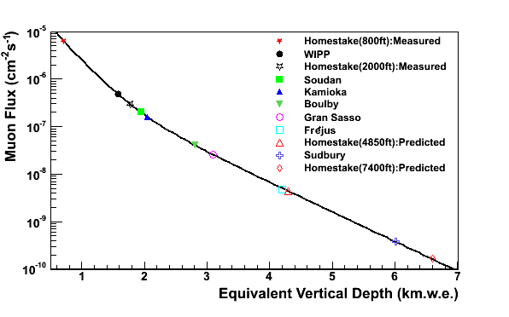

Figure 2. Integrated muon flux as a function of depth, compared against a flat-earth model. This model is used to extrapolate to the 4850 and 7400 ft level at Homestake.

[1] M.L. Cherry, et al., Phys.Rev.D 27(1983)1444.

[2] F.E. Gray, et al., NIMA 638(2011)63-66.

[3] D.-M. Mei, A. Hime, Phys. Rev. D 73(2006)053004.