**Muon Spectra vs Depth**

Muon rates and energy spectra as a function of depth are taken from parameterization described in [Mei2005], using the flat overburden equivalent for all sites. Rates verified within factor of two of measurements. Energy spectra may differ by factor of a few at low energies, but match well for TeV or higher muons. TeV or higher muons contributed X% of total cavern neutron flux, so discrepancies at lower energies vary results by a factor of Y.

Muon energy spectra are compared for Homestake 4850, Soudan, and SNOLAB sites in Fig. [fig:muon-E-spectra]. These spectra are normalized for rate and their respective shapes are compared directly in Fig. [fig:muon-E-spectra-norm]. The energy spectra feature a crossover point near 170 GeV, providing a useful point for comparing relative proportions of high- and low-energy muons for various depth spectra. It should be noted that, for the range of this comparison, the low-energy spectral component varies from 64% of total (for Soudan) to 48% of total (for SNOLAB), while for Homestake it comprises 51% of total. The slope of the high-energy rolloff is also constant with power 3.77. The primary variation in muon-induced backgrounds is therefore expected to stem from differences in the overall muon flux for a various sites, rather than the change in spectral shape with depth.





 Figure 1. Left: Muon energy spectra as a function of depth, taken from the parameterization described in [Mei2005]. Right: Same spectra normalized by area for comparison of shape.

** Chao writes: The differential muon flux at 4850 ft (4.4 km.w.e) level at Homestake was measured by Cherry et al.[1] at early 80s. In order to characterize the muon flux as function of depth, the cosmic ray muon flux was measured in different depth of Homestake Mine by using plastic scintillation counters[2]. The nearly vertical muon flux was obtained in three locations: on the surface(1.149e-2 cm^{-2}s^{-1}sr^{-1}), at the 800ft level(2.67e-6 cm^{-2}s^{-1}sr^{-1}), and at the 2000ft level(2.56e-7 cm^{-2}s^{-1}sr^{-1}). These fluxes agree well with model predictions[3]. The integrated muon fluxes for different depth are compared in Figure 2.

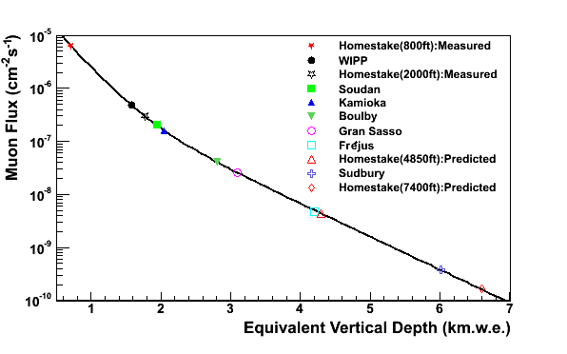

Figure 2. Integrated muon flux as a function of depth, compared against a flat-earth model. This model is used to extrapolate to the 4850 and 7400 ft level at Homestake.

[1] M.L. Cherry, et al., Phys.Rev.D 27(1983)1444.

[2] F.E. Gray, et al., NIMA 638(2011)63-66.

[3] D.-M. Mei, A. Hime, Phys. Rev. D 73(2006)053004.