**Evaluating Neutron Backgrounds in Dark Matter Searches**

**I. Introduction**

The degree to which backgrounds are reduced by siting an experiment underground is crucial to the design of dark matter experiments, yet it is very difficult to estimate. This is especially true of the high-energy neutrons produced by cosmic rays. These heavy neutral particles cause nuclear recoils in target material that are hard to distinguish from WIMPs. Shielding strategies are therefore a major technical consideration and drive cost in a non-trivial fashion.

Design of shielding and choice of technology rely on detailed simulations of these backgrounds. However, cosmogenic simulations have large uncertainties since measurements sensitive to neutron flux and multiplicity are difficult and data is scarce. High-energy neutrons themselves are not easy to detect and the experiments that would do so require lengthy run times due to low rates underground. In other words, those variables which would inform the physics models used in the simulations are not well-measured.

Combine this with a two very different simulation strategies, embodied in the GEANT4 and FLUKA codes, as well as non-standardized definitions and input variables, and confusions can easily arise in comparing backgrounds expected in different detectors at different sites and overburdens.

It is the purpose of this paper to be a reference source for information about cosmogenically-induced neutron backgrounds and their associated uncertainties. We therefore start by cataloguing relevant data from those experiments that are uniquely sensitive to such backgrounds. After reviewing the data and understanding discrepancies, we investigate the uncertainties inherent in the simulation codes themselves, as well as their application to various technologies. This is accomplished by detailing differences between FLUKA and GEANT4 for simple processes such as muon-induced neutron yield in a selection of target materials, as well as comparing the simulated backgrounds in three major dark matter technology choices with the same shielding, definitions, and incoming muon distribution. This results in an improved understanding of sources of uncertainties in cosmogenic simulations for dark matter experiments.

Bottom of Form

**II. Existing Measurements of Underground Neutron Backgrounds**

Traditionally, underground experiments estimate their neutron backgrounds using extensive simulation specific to their configuration and normalized to a handful of events in their well-shielded target mass. This leads to large error bars and systematic uncertainties between technologies. Understanding the origins of these discrepancies requires examination of the subset of dark matter experiments with specific strategies for detecting and evaluating cosmogenic neutrons. Their results can be used to improve the physics and implementation of the simulation package(s) used by all experiments. The current status of these experiments is outlined below.

We start with an historical review of LSD and LVD, which produced some of the first neutron yield measurements in liquid scintillator. Discrepancies between the two experiments could not be properly explained by either FLUKA or Geant, which also disagreed with each other. The discrepancies are reduced significantly with better accounting of neutron capture in iron, new LVD data, and improvements in the two simulation codes. Next we summarize findings from experiments with large liquid scintillator tanks (Kamland, SNO, and Borexino), which provide a chance to directly evaluate simulation codes in a simple geometry with good timing and particle ID. Production in gadolinium-loaded liquid scintillator is explored by LSM and estimates of neutron yield in lead is provided by ZEPLIN II and III. A new initiative at Soudan combines muon tracking with a gadolinium-doped water tank on top of a lead target.

**II-A. Older Measurements of muon-induced neutrons with LVD and LSD**

Two experiments performed at the end of 80’s (LSD) and the end of 90’s (LVD) involved similar liquid scintillator detectors at two different underground sites. LSD was located in the tunnel under Mont Blanc, whereas LVD has undergone upgrades over time and is still being operated at LNGS in Gran Sasso. LSD used 72 scintillation counters in total, whereas the LVD measurement used the data from 304 counters. Only data from inner counters with smaller background rate were analysed in the search for muon-induced neutrons in both experiments. Each counter contained about 1.2 tonnes of liquid scintillator. Both experiments recorded pulses from neutron capture in delayed coincidences with muon triggers. Due to a much higher detection efficiency for neutrons in those counters which also contained a muon track or muon-induced cascade, only pulses detected in the same counter as the muon pulse were analysed. The energy threshold for neutron detection was set at about 0.5-1 MeV. Muon trigger conditions were different: LSD triggered directly on the liquid scintillator signal, requiring either a high energy deposition in one counter (greater than 25 MeV) or a time coincidence between at least two scintillators; LVD required a trigger from an independent tracking system as well. Their tracking information came from a set of limited-streamer tubes positioned on one side and beneath each counter.

In both experiments the calibration of the detectors was done using neutron sources, with the neutron detection efficiency determined from comparing the resulting data to a simple Monte Carlo for these neutrons. A fit to the measured time delay distribution of neutron capture pulses with respect to the muon trigger consisted of a single exponential plus a flat background. The background was estimated from a separate sample of delayed pulses in counters which were not intersected by muons. Note that this sample of pulses also included a small fraction of neutron captures, since neutrons can be detected at large distances from a muon track and hence in the counters without a muon. Note also that the time distribution of neutron captures can be fitted by a single exponential only if neutron production, moderation, and capture occur within the same material, assumed here to be scintillator. Later simulation work proved that this assumption was wrong; see section on new measurements with LVD.

The mean energy was calculated to be 270 GeV for LVD and 380 GeV for LSD. Later on more accurate calculations gave the value for the depth of LSD (about 5200 m w. e.) to be about 310 GeV. The neutron yield in scintillator in both papers was calculated using the equation:, where *Nμ* is the number of detected muons, *Q* is the fraction of neutrons produced in scintillator (0.85 for LVD and 0.61 for LSD with a much higher mass of iron), *l* is the mean track length of a muon in the LVD/LSD scintillator and *ε* is the neutron detection efficiency. The factors *Q*, *l* and *ε* were calculated using a simplified Monte Carlo or estimated without proper modelling. *Nn* is the number of detected neutron captures for the infinite time window after the muon trigger, and was obtained from the fit to the measured distribution with a single exponential and a flat background.

The results reported in the papers are: (1.5±0.4)×10-4 neutrons/muon/(g/cm2) for scintillator in LVD and (5.3±1.0)×10-4 neutrons/muon/(g/cm2) for LSD. This obvious difference between two results which were obtained for the same type of scintillator set up and a similar depth remained a concern for many years in the field and resulted in large uncertainties being attributed to background estimates based on cosmogenic simulations. In addition, new results from LVD showed a significantly bigger value than earlier LVD results (by about 2 standard deviations) and smaller than the early LSD result (also by about 2 standard deviation, although mean muon energy at LSD is higher than at LVD). By looking carefully at the experimental details and simulation limitations, we can see more clearly the cause of these inconsistencies. To summarize:

1) Neither LVD nor LSD early analyses were accompanied by accurate simulations of neutron production, transport and detection since they were simply not available at the time. Thus, no direct comparison could be made between measured and simulated neutron capture event rate.

2) The absence of an accurate Monte Carlo for the high-energy neutrons led to a confusion concerning which material was being evaluated for the neutron yield. The results were quoted for scintillator, whereas it has since been shown by LVD that most of detected neutrons were produced in iron. This should also be true for LSD, although no simulations have been performed. Hence the factor *Q* has a large uncertainty factor, which was not been taken into account in the reported results.

3) Neutron detection efficiency for both experiments was evaluated using a Cf neutron source inside the scintillation counters. However, we now know that the muon-induced neutrons were produced mainly outside the scintillator in iron, and have higher energies than the source neutrons. This most likely resulted in an overestimate of the calculated neutron detection efficiency in both experiments.

4) The old and new LVD data and analysis were based on different data sets and selection cuts as follows: a) the new data does not depend on a trigger from the tracking system; b) the new data includes 3 LVD towers instead of just one; c) the new data set was taken from the counters not crossed by muons, thus removing neutron capture pulses which previously introduced bias in the time delay distribution. Thus, the fraction of detected neutrons is much smaller and their energy somewhat higher since the detected neutrons have travelled further from their production point to their capture point.  
  
In conclusion, we believe that the old data from the LSD and LVD experiments, when properly interpreted, do provide a good test of the muon-induced neutron production, but their systematic uncertainties were underestimated. In the absence of full simulation, it is impossible to directly compare the measured and simulated rates of neutron capture pulses within a certain energy range and time window after the muon trigger, which could have provided a crucial test of the model. The LVD also reported the energy spectra of neutron-induced events and the distribution of neutron capture pulses as a function of the distance from the muon track. While this information is important for understanding the emission of neutrons and their transport, it again cannot be properly interpreted without full neutron production/transport Monte Carlo.

*II-A. References*

*M. Aglietta et al. (LVD Collaboration). Proc 26th ICRC (Salt Lake City, August 1999),* arXiv:hep-ex/9905047v1

*M. Aglietta et al. (LSD Collaboration). Il Nuovo Cimento, 12, 467 (1989)*

**II-B. New Measurements of muon-induced neutrons with LVD at LNGS**

The LVD experiment consists of 735 liquid scintillator counters arranged in three towers. Each counter contains ~1.2 tons of scintillator, totalling a kiloton in all. It is located at the Gran Sasso Laboratory (LNGS), which does not have a flat overburden. The minimum depth of LNGS is slightly less than 3000 m w.e., whereas the mean depth (weighted by the muon flux) is about 3650 m w. e.

In order to identify muon-induced neutrons, LVD recorded the delayed coincidences between the parent muon signal and pulses due to neutron capture (mainly on hydrogen but also on other elements). Neutron capture pulses were divided into two classes depending on whether the capture occurred in a scintillation counter with a muon-like trigger (class 1) or not (class 2). Extensive calibrations with gamma and neutron sources demonstrated that the time delay distribution of class 1 neutron capture pulses does not match either the simulation (GEANT4, version 9.3) nor the neutron source data. This is due to the large overshoot produced by a muon or muon-induced cascade, which results in a large number of neutron capture pulses being undetected. For class 2 events, the measured time delay distribution agrees with both simulation and neutron source calibrations. The class 2 neutron capture pulses with energies between 1-5 MeV and within a 20-400 μs time window after the muon trigger were selected for further analysis. The muon trigger was defined as the time coincidence within 250 ns of at least two pulses in two different counters with an energy deposition in each counter exceeding 10 MeV. The sample of pulses with these selection criteria was dominated by random coincidences of the muon triggers accompanied by background pulses caused by radioactivity with a small admixture of neutron capture pulses. The flat background from random coincidences was evaluated by considering events caused by radioactivity without muons. In these events, since no muon is present, it is highly unlikely to see neutron captures.

During 1440 days of live time, ~ 7.7 muons were detected. The measured time delayed distribution of pulses after the muon trigger (20-400 μs time window) has been compared to the simulated one using the same event selection criteria. A flat background component determined from events with a different trigger (see above) has been added to the simulated distribution. Simulations have been carried out with GEANT4 v9.3. The direct comparison of measured and simulated time delay distributions has revealed that the measured number of neutron captures exceeds the GEANT4 v9.3 simulations by about 30-40%.

Assuming that the deficit of neutron captures in simulations is caused by the deficit of neutron production and that the percentage deficit of neutron production in simulation is the same for iron and scintillator, the LVD Collaboration has scaled up the calculated neutron yield in iron and scintillator by the same factor (30-40%). Their preliminary values for the neutron yield at a mean muon energy of 280 GeV are:

Iron (evaluated from data): *Y* = (1.5±0.3)×10-3 n/muon/(g/cm2)

Liquid Scintillator (evaluated from data): *Y* = (2.9±0.6)×10-4 n/muon/(g/cm2)

Note that 84% of muons are produced in iron according to simulations, so the uncertainty of the result for scintillator may be quite large. In other words, the sensitivity of the total neutron capture rate to the neutron production in scintillator is small. The result for scintillator relies on the assumption that the percentage deficit in simulated neutron yield is the same for iron and scintillator.

**References**

*R. Persiani et al for the LVD Collaboration. Poster at the LRT2013 Workshop (LNGS, Italy, April 2013).*

*M. Selvi for the LVD Collaboration. Talk at the Intern. Workshop on Cosmogenic Activation and Backgrounds (CAB 2011, Berkeley, April 2011).*

**II-C. Kamland** The experiment consisted of a large, unsegmented liquid scintillator detector. The active detector region contained about 1 kton of ultra-pure liquid scintillator (LS) inside a 13 m diameter spherical balloon made of 135 µm thick transparent nylon composite film. The LS cosisted of 80% dodecane, 20% pseudocumene (1,2,4-Trimethylbenzene) by volume, and 1.36 ± 0.03 g/l of the fluor PPO (2,5-Diphenyloxazole) with a density of 0.780 g/cm3. A buffer composed of isoparaffin and dodecane oils filled the region between the balloon and the surrounding 18 m diameter spherical stainless-steel outer vessel to shield the LS from external radiation. An array of 1325 17-inch photomultiplier tubes were mounted on the inner surface of the outer containment vessel to view the sensitive target region with an approximate photocathode coverage of 22%.

The KamLAND experiment presented neutron and isotope production rates from cosmogenic muon-initiated spallation in liquid scintillator based on data collected from 5 March 2002 to 12 May 2007 [K]. The experiment was located in the Kamioka mine at an approximate depth of 2700 meter water equivalent. An average muon flux of 5.37 ± 0.41 m-2 h-1 was measured by KamLAND. This flux corresponds to the muon event rate since muon bundles were not identified. The mean residual muon energy at the depth of the experiment was reported as 260 +/- 8 GeV from simulation since no experimental values are available.

Results for the cosmogenic production yield of several radioisotopes and neutrons were reported and compared to predictions from a FLUKA simulation. The measured neutron yield is given as Y= (2.8 +/- 0.3) x 10-4 n/(m g/cm2). It should be noted that the reported neutron yield was based on a fit and extrapolation to the neutron capture time distribution. Only a small subset of the recorded neutrons was considered for the fit with capture times > 6   because of the effects of the large prompt muon signal on the electronics. Hence, the assigned systematic uncertainty is optimistic.

KamLAND reported the cosmogenic production yield for 11C with (0.87 +/-0.3) x 10-4 11C/( g/cm2). A 96% probability of the coincident production of a free final state neutron for this reaction is also stated. Hence, about one third of all cosmogenic neutrons produced in liquid scintillator at the depth of the Kamioka mine are the result of 11C production.

**II-D. Borexino as a Neutron Background Detector**

Borexino is a low-energy solar neutrino spectroscopy experiment located in Hall C at LNGS. The detector features a well-shielded, unsegmented organic liquid scintillator target of 278 tonnes, which provides a uniform angular response to cosmogenic muons because of its spherical shape. Tracking information for cosmogenic muons is provided by the outer veto detector systems. The inner sensitive target volume is viewed by 2200 optical sensors which record neutron capture signals in the time window [30-1600] µs after a muon trigger. Details about the detection of cosmogenic muons and neutrons in Borexino are given in [1] and the most recent measurement of the muon flux at LNGS for Hall C of (3.41 +/- 0.01) x 10-4 m-2 s-1 was published in [2]. This flux reflects the cosmogenic muon event rate since multi-muon events, i.e. muon bundles, are not resolved in Borexino. The average depth for LNGS is approximately 3800 mwe and the residual muon mean energy at LNGS of 283 +/- 19 GeV was measured by the MACRO experiment [M].

Borexino offers the unique possibility for a precise study of cosmogenic muon-induced neutrons inside a large uniform volume of liquid scintillator due to its simple geometry, large and well-shielded target mass, and excellent event reconstruction capability. The analysis procedure and results for cosmogenic backgrounds in Borexino as well as a comparison to prediction from Geant4 and FLUKA are reported in [3]. In general, good agreement between data and simulation was found. The experimental results currently provide the most precise information on cosmogenic neutron and isotope production in liquid scintillator at great depth.

An overall neutron capture detection efficiency of (91.7 +/- 1.7stat +/- 0.9syst)% was determined for the applied time window. Further, the fraction of neutrons to capture within the time window was (89.1 +/- 0.8)%.. The contamination of the measured capture time spectrum with uncorrelated events was found to be (0.5 ± 0.2) %. The data used for the study corresponds to a period of 559 live days and was obtained between January 2008 and February 2010.

The reported neutron capture yield is (3.10 +/- 0.07stat +/- 0.08syst) x 10-4 n/muon/(g/cm2) for liquid scintillator at LNGS. 11C is one of the measured radioisotopes and the reported production yield is (0.886 +/- 0.115) x 10-4 n/muon/(g/cm2). As suggested [Cr], in 95% of the 11C production a free final state neutron is expected. The results indicate that approximately 27% of all cosmogenic neutrons produced in liquid scintillator at LNGS depth are created in conjunction with 11C. Further, the neutron capture multiplicity distribution as well as the lateral distance distribution between neutron capture locations and parent muon track are also provided.

*II-D. References*

1. G. Bellini et al., “Muon and Cosmogenic Neutron Detection in Borexino”, JINST, 6, p05005, 2011

2. G. Bellini et al., “Cosmic-muon flux and annual modulation in Borexino at 3800 m water-equivalent depth”, JCAP, 05, p015, 2012

3. G. Bellini, et al., “Cosmogenic Backgrounds in Borexino at 3800 m water-equivalent depth”, arXiv:1304.7381, 2013

4. A. Empl, R. Jasim, Ed Hungerford and P. Mosteiro "Study of Cosmogenic Backgrounds at LNGS", arXiv:1210.2708, 2012

K. Abe, S. et al, “Production of radioactive isotopes through cosmic muon spallation in KamLAND", Phys. Rev. C 81, arXiv:hep-ex/0907.0066, 2010

G. C. Galbiati et al.,"Cosmogenic 11C production and sensitivity of organic scintillator detectors to pep and CNO neutrinos", Phys. Rev. C71, 055805, 2005

**II-E** **Measurements of muon-induced neutrons at LSM**

The Modane Underground Laboratory (LSM) is located at a mean depth of approximately 4800 m w. e. with a mean muon energy of about 300 GeV. The measurements were performed using a one-ton (1 m3) liquid scintillator detector doped with ~0.2% of gadolinium. The measured muon event rate was consistent with a muon flux of 7.64×10-9 cm-2 s-1 into a spherical surface. The scintillator cell rested on a large lead block, so that most of the muon-induced neutrons have been produced in lead.

Neutrons were observed via their radiative capture on the gadolinium and other isotopes. The signal was identified by its delay time with respect to either the muon trigger or another pulse linked to the muon capture in the same muon event. Pulses from neutron-capture gamma rays were observed above an energy threshold of 1 MeV in a time window of 60 μs after the muon trigger. Detector calibration was achieved using both gamma ray and neutron sources. The measured time delay distributions of the neutron capture pulses from both the Am-Be source and cosmic muons agree well with each other and with the simulation carried out with GEANT4 toolkit, version 9.2, with a physics list similar to QGSP-BIC-HP.

During the 608 days of running time, 3507 muon events were accumulated, 123 of which had at least one secondary pulse above the energy threshold of about 1 MeV in a time window of 60 μs after the muon trigger. The total number of neutron captures was 203. A similar analysis was performed on events triggered by a train of at least two low-energy pulses, a class of events assumed to mostly consist of captures from secondary neutrons. Again, the resulting time distribution was similar to that measured with the Am-Be source. The number of this class of events was ~800 with a non-negligible background. The energy spectra and neutron multiplicity distributions have been reported, as have the simulation results and calibration with the Am-Be source.

Preliminary results indicate that the measured number of neutron capture pulses agrees within 20% with the GEANT4 simulations (v9.2). The analysis is in progress and the final results are expected by summer 2013.

*II-G References*

*V. Kozlov for the EDELWEISS Collaboration. Poster at the LRT2013 Workshop (LNGS, Italy, April 2013).*

*K. Eitel for the EDELWEISS Collaboration. 12th Intern. Conf. on Topics in Astroparticle and Underground Physics (TAUP 2011). IOP Publishing. Journal of Physics: Conference Series* ***375*** *(2012) 012016*

**II-F. Muon-induced neutrons in the SNO experiment.**

The SNO detector is located in SNOLAB which shares space with a working copper-nickel mine in Sudbury, Canada at a depth of 5890 m.w.e. The depth, combined with a flat overburden, results in mostly vertical muons with zenith angles less than cos  < 0.4. The SNO detector was built to measure solar neutrino flux from the 8B decay and consists of a 600.5 cm radius acrylic vessel filled with 99.92% isotopically pure heavy water. The 5.5-cm thick acrylic vessel is surrounded by 7.4 kilotons of ultrapure water observed by more than 9000 phototubes. Muon tracks are well-reconstructed using Cerenkov light from the tubes and estimated energy loss. A test using an external wire chambers demonstrated an accuracy better than 0.62o +- 0.12o.

The first phase of SNO used pure D2O. In the second phase, salt was added to enhance neutron sensitivity via 35Cl capture. In a third phase, a set of helium proportional tubes were inserted into the detector to make an independent measurement of the neutron via capture on 3He.

**II-G. Measurements of muon-induced neutron yield in lead using ZEPLIN-II**

Muon-induced neutron yield was measured using 0.73 tons of liquid scintillator that also served as an anticoincidence system for the ZEPLIN-II direct dark matter experiment at the Boulby Underground Laboratory. The vertical depth of the laboratory is 2850±20 m.w.e., corresponding to a mean muon energy of 260 GeV. The muon flux was measured to be

(3.79 ± 0.04 (stat.) ± 0.11 (syst.))×10-8 cm-2 s-1.

The experimental method exploited delayed coincidences between the parent high-energy muon signal and gamma rays from radiative neutron capture on hydrogen or other elements. The response of the detector to neutrons was determined using an Am-Be source. It showed good agreement between the measured and calculated time delay distributions, where the delay is defined between the trigger pulse (induced in this case by proton recoils or prompt gammas) and the neutron capture pulse. The energy calibration of the detector was carried out using a 60Co source, as well as by comparison between the measured and simulated spectra of gamma-ray events in the liquid scintillator.

10832 muons and 1037 neutron capture pulses above 0.55 MeV in a time window of 40–190 μs after the muon trigger were detected during 205 days of running time. The measured time delay distribution, energy spectrum of captured gammas (mainly on hydrogen) and the neutron multiplicity distributions have been compared to the simulations and to the background events when the trigger was caused by gamma rays from radioactivity rather than muons. The time delay distribution of background events was found to be flat, whereas that of the muon-induced events showed a characteristic exponential-like shape caused by neutron capture process. Note that the time distribution of neutron capture events is not exactly exponential since the neutron production, moderation and capture occur in different, separated in space materials (mainly lead for neutron production and mainly hydrogen for neutron moderation and capture). The muon-induced neutron capture rate, defined as the average number of detected neutrons per detected muon, was measured as 0.079±0.003 (stat.) neutrons/muon using pulses above 0.55 MeV in a time window of 40–190 μs after the muon trigger.

Monte Carlo simulations of the experiment used MUSUN to generate muon energy and angular distributions at Boulby. Muons were sampled on the surfaces of a rectangular parallelepiped that surrounded the experimental hall and all secondary particles were tracked into a precise model of the laboratory and experimental setup using the GEANT4 toolkit version 8.2. The simulation gave a result 1.8 times higher than the measured value, namely 0.143 ± 0.002 (stat.) ± 0.009 (syst.) neutrons/muon. This difference greatly exceeded all statistical and systematic uncertainties.

90% of neutrons detected in the setup were produced in the lead which surrounded the detector from all sides. The main contribution came from lead positioned on 4 sides around the detector and beneath the detector since the scintillator was shielded from lead in the roof section by the Gd-loaded polypropylene. Two runs with roof-lead-section on and off gave consistent results, in agreement with simulations. The neutron yield in lead, defined as the number of neutrons produced by a muon per g/cm2 of its track, was then evaluated by scaling the calculated yield by the ratio of measured-to-calculated neutron capture events (e.g. 1/1.8). To calculate the neutron yield in lead, monoenergetic muons were transported through 3200 g/cm2 of lead and only neutrons produced in the middle 1600 g/cm2 were counted. This gave a neutron yield or production rate of (1.31±0.06)×10-3 neutrons/muon/(g/cm2) for a mean muon energy of about 260 GeV.

A new simulation of the ZEPLIN-II setup has been performed with the most recent version of GEANT4.9.5 at that time with the physics list Shielding, accurate thermal scattering cross-sections and much larger sample of muons than previously, to compare the ZEPLIN-II and ZEPLIN-III results. The new simulations for ZEPLIN-II gave significantly smaller neutron capture rate compared to the old result and closer to the measured capture rate. When converted to the neutron production rate using the procedure described above, the measured neutron production rate in lead was found to be (3.4±0.1)×10-3 neutrons/muon/(g/cm2). Although the new simulations bring the calculated neutron production in lead closer to the measured one with the ZEPLIN-II veto setup, calculated yield is still about a factor of 1.35 higher than the measured one. New measurements using ZEPLIN-III veto showed a rate about a factor of 1.7 higher than the ZEPLIN-II result. One possible explanation is that the angular distribution of emitted neutrons may not be accurately modeled. The two setups have different arrangements of lead and shielding and this could affect the results.

*II-G References*

*H. M. Araújo et al. Astroparticle Physics 29 (2008) 471–481*

*L. Reichhart et al. submitted to Astroparticle Physics, arXiv:1302.4275v1 [physics.ins-det] 18 Feb 2013*

**II-H. Measurements of muon-induced neutrons in lead using ZEPLIN-III active veto system**

This experiment was carried out with 52 plastic scintillators, which also served as an anticoincidence system for the ZEPLIN-III direct dark matter experiment at the Boulby Underground Laboratory. The vertical depth of the laboratory is 2850 m w. e. which corresponded to the mean muon energy of 260 GeV. The muon flux was measured as (3.75±0.09)×10-8 cm-2 s-1, in agreement with previous measurements.

The experimental method exploited the delayed coincidences between high-energy muon signals and gamma rays from radiative neutron capture on hydrogen or other elements. 95% of all detected neutrons were produced in the 60-ton lead shielding around the ZEPLIN-III dark matter detector and its scintillator veto system.

7979 muons have been selected for neutron capture analysis with a rate of 32.3±0.4 muons per day. Neutron capture pulses were required to have at least 10 detected photoelectrons and to occur in a time window of 40–300 μs after the muon trigger. The measured time delay distribution and the neutron multiplicity distributions have been compared to the simulations and to the background events when the trigger was caused by a background event in the ZEPLIN-III two-phase xenon detector. The time delay distribution of background events, caused by gamma-rays from radioactivity, was found to be flat whereas that of muon-induced events has shown a characteristic exponential-like shape caused by neutron capture process. Note that the time distribution of neutron capture events is not exactly exponential since the neutron production, moderation and capture occur in different, separated in space materials (mainly lead for neutron production and mainly hydrogen for neutron moderation and capture). The muon-induced neutron capture rate, defined as the average number of detected neutrons per detected muon, was measured as 0.346±0.007 (stat.) neutrons/muon using pulses with an amplitude greater than 10 photoelectrons in scintillators and in a time window of 40–300 μs after the muon trigger. Monte Carlo simulations of the neutron production, transport and detection in a precisely modeled laboratory and experimental setup using the GEANT4 toolkit version 9.5 with the physics list Shielding gave a neutron capture rate of 0.275 ± 0.003 (stat.) (+ 0.004 – 0.007) (syst.) neutrons/muon, which is 26% smaller than the measured rate.

To calculate the neutron yield in lead, defined as the number of neutrons produced by a muon per g/cm2 of its track, mono-energetic negative muons were transported through 3200 g/cm2 of lead and neutrons produced in the middle 1600 g/cm2 of this lead block were counted. This gave the neutron yield or production rate as 4.594×10-3 neutrons/muon/(g/cm2) for a mean muon energy of about 260 GeV. Since the experimentally measured neutron capture rate was found to be 26% higher than the full-scale simulation result, to determine the neutron production it is possible to scale up the calculated neutron yield for a block of lead by a factor of 1.26. Hence, the neutron yield in lead has been evaluated from the experimental data as (5.8 ± 0.1 (stat.) (+ 0.2 – 0.1) (syst.))×10-3 neutrons/muon/(g/cm2).

The comparison of simulations carried out with several versions of GEANT4 and different physics lists have revealed a general trend of increasing neutron production in lead with any new version of GEANT4 until the most recent to date, namely 9.5. Physics list Shielding gives the highest neutron production rate among other tested lists. The sources of these differences have been investigated and reported.

*II-H References*

*L. Reichhart et al. To be published in Astroparticle Physics, arXiv:1302.4275v1 [physics.ins-det] 18 Feb 2013*

**II-I. The Soudan Muon Shielded room and Neutron Multiplicity Meter**

This experiment is the newest entry in the effort to benchmark muon-induced neutrons underground and deploys individual neutron detectors time-synched to a surrounding muon tracker. The neutron multiplicity meter (NMM) is a 4-ton gadolinium-doped water Cerenkov detector situated on top of a 40 cm thick lead target \cite{henningsyeomans}. The lead target acts as a fast neutron converter, allowing 100 MeV-scale neutrons to be detected through $(n,kn)$ reactions induced in the lead. The secondary neutrons, with MeV-scale energies, are then thermalized in the water volume and captured on gadolinium nuclei. De-excitation of the gadolinium results in a shower of gamma rays summing to approximately 8 MeV, detected by the Cerenkov light emitted from subsequent Compton-scattered electrons in the water volume. The detected neutron multiplicity is roughly correlated with the incident neutron energy, and a multiplicity threshold of 5 corresponds to approximately 40 MeV. This is the only known measurement of muon-induced neutron production anti-coincident with a muon traversing the detector volume at 2 km.w.e. A fully calibrated Geant4 simulation \cite{sweanythesis} is used to estimate the accuracy of the predictions presented in \cite{meiandhime}. The NMM collaboration \cite{nmmcolab} is currently working to better understand non-neutron backgrounds and incorporate greater statistics into the data analysis before publishing a definitive comparison of their observed event rate to the simulated fast-neutron flux, where the spectrum of simulated neutrons entering the Soudan cavern is modeled parametrically according to \cite{meiandhime}. Additionally, simulations of single muons following \cite{music/musun} within a realistic cavern geometry are being performed, providing a cross check to the \cite{meiandhime} parameterization and allowing a more robust validation of Geant4 and FLUKA modeling.

Needs to be updated! (Anthony, Ray?)

*II-I. References*

\bibitem{nmmcollab} http://neutron.physics.ucsb.edu/

\bibitem{henningsyeomans} R. Hennings-Yeomans and D.S. Akerib {\it Nuclear Instruments and Methods in Physics Research A} {\bf 574} (2007) 89-97

\bibitem{sweanythesis} M.D. Sweany {\it Ph.D. Thesis, University of California at Davis} (2011)

\bibitem{meiandhime} D.-M. Mei and A. Hime. {\it Physical Review D} {\bf 73} (2006) 053004

\bibitem{music/musun} V. A. Kudryavtsev. {\it Computer Physics Communications} {\bf 180} (2009) 339-346

**II-J. Conclusions and Comparisons.**

While we have reviewed the major newer experiments, one should note that the muon-induced neutron yield has been measured at various depths at underground sites over the last 60 years. Early experiments were carried out in Russia (USSR) and the experimental results were preceded by the theoretical work of G. T. Zatsepin and O. G. Ryazhskaya in 1965 [1] (who also led the measurements). Their calculations predicted the muon-induced neutron yield to be a function of mean muon energy and to follow a simple power law with the normalization obtained from fits to experimental data. The interest in muon-induced backgrounds and the neutron yield at that time was motivated by the first atmospheric and solar neutrino experiments [2].

While experimental data for the neutron yield has been reported for liquid scintillator, experimental groups have not always taken care to prove that the primary neutron production is in the scintillator. The experimental data are shown as a function of mean muon energy in Figure X together with the early prediction derived from [1] given by the thin black line for both linear (left) and double logarithmic (right) scale. As pointed out in section ??, the older experimental results which are shown by the solid black symbols require careful interpretation. No detailed MC simulations were available to aid the data analysis at the time and to convert the measured rate of captured neutrons into the neutron production rate in a specific material (scintillator). This is particularly important since the data was obtained either with relatively small detectors and/or with large detectors of mixed target materials. The lack of proper simulation tools also impacts the quoted mean muon energies. The unmodified and originally reported values for mean muon energy and neutron yield are shown in Figure X.

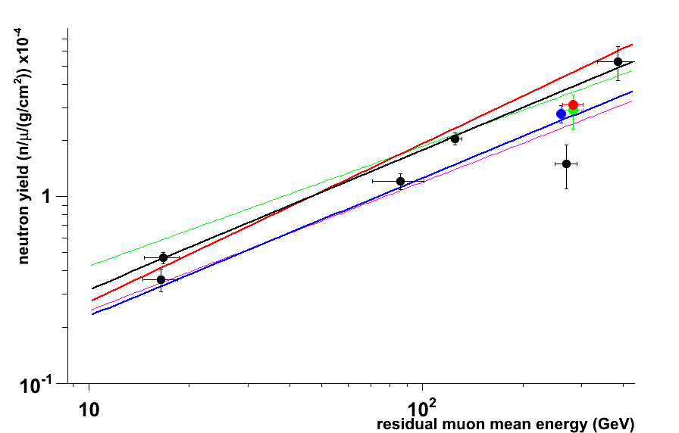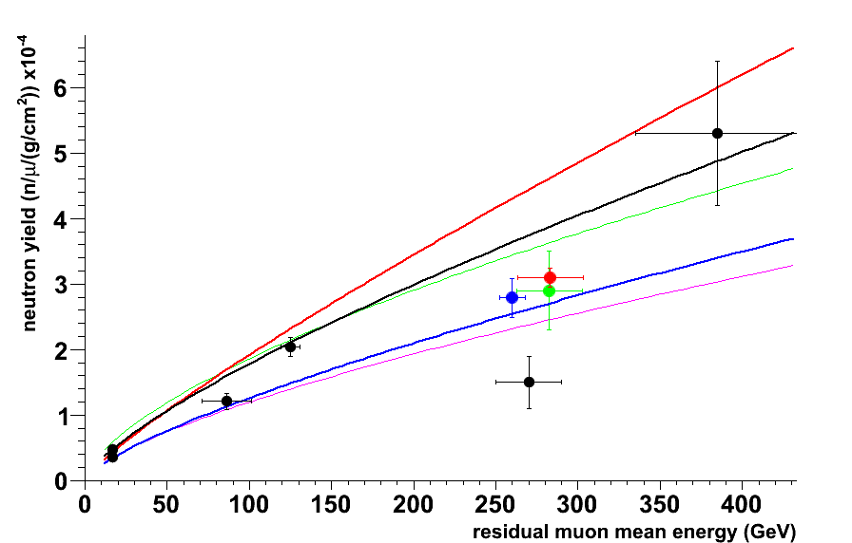

Figure X: Muon-induced cosmogenic neutron yield. The old experimental data are given by the solid black symbols. Sorted by increasing mean muon energy (in GeV) they are: Boehm et al (16.5) [3], Bezrukov et al (16.7, 86) [4], Enikeev et al (125) [5], Aglietta et al (270) [6] and Aglietta et al (385) [7]. The new results from KamLAND [8] (solid blue symbol), LVD [9] (solid green symbol) and Borexino [10] (solid red symbol) are also shown. The experimental values are compared to predictions for the neutron yield derived by G. T. Zatsepin and O. G. Ryazhskaya 1965 [1] (thin black line normalized to the experimental data known at that time), Wang et al 2001 [11] (thick blue line), Mei & Hime 2006 [12] (thick red line), Geant4 4.9.5p01 (thin green line) and FLUKA 2011.2.17 [13] (thin purple line).

Further, three modern results obtained at the Kamioka mine by the KamLAND experiment (blue symbol) and at LNGS by the LVD (green symbol) and Borexino (red symbol) experiments are also available. These new results are based on large detectors and the data analysis is supported by detailed MC simulations. In particular, the exceptional efficiency to record more than 80% of all cosmogenic neutron captures in coincidence with muon events in a large, ultra pure and homogeneous detection volume greatly reduce systematic uncertainties for the Borexino result.

Also shown in Figure X are two frequently quoted parameterizations proposed to describe the cosmogenic neutron production yield as a function of mean muon energy. A simple power law behavior with Nn=4.14∙Eμ0.74∙10-6 n/(μ g/cm2) was obtained by making use of the FLUKA simulation program (Wang et al, 2001 [11]) which is shown by the thick blue curve. The thick red line corresponds to Nμ=3.824∙Eμ0.849∙10-6 n/(μ g/cm2) which was derived from a fit to the somewhat modified old experimental data (Mei & Hime, 2006 [12]). Other parameterization based on FLUKA and GEANT4 simulations have also been proposed but are not included on Figure X (see, for instance, [14]). Finally, the results of simulating the cosmogenic muon-induced neutron yield with current versions of the Geant4 (thin green line) and FLUKA (thin purple line) simulation tools in context of the AARM project [13] are also given.

A number of experiments have recently reported the neutron production rate in iron [9] and lead [15,16,17]. They have been carried out at large depths underground with corresponding mean muon energies within the narrow range of 260-300 GeV so no energy dependence can be extracted from these measurements. They are, however, very useful in predicting the neutron background in current and future high-sensitivity rare event searches.

[1] G. T. Zatsepin and O. G. Ryazhskaya, Proc. Of the 9th ICRC, Vol 3, London, 1966

Izv. Akad. Nauk SSSR, Ser. Fiz. 29, 1965

[2] Kolar Gold Fields

East Rand Propriatory Mine

Davis experiment, Homestake

[3] “Neutron production by cosmic-ray muons at shallow depth”,

F. Boehm et al, Phys.Rev. D 62, p 092005, 2000, arXiv:hep-ex/000601

[4] “Investigation of Depth-Intensity Curve of Nuclear Events Induced by Muons”,

L. B. Bezrukov et al, Proc. of the 13th ICRC, Denver, Vol 3, 1947

Yad. Fiz. 17, 98 1973 (Sov. J. Nucl. Phys. 17, 51 1973)

[5] “Hadrons generated by cosmic-ray muon underground”,

R. I. Enikeev et al., Yad Fiz. 46, 1492 1987 (Sov. J. Nucl. Phys. 46, 883 1987)

“Hadrons and Other Secondaries Generated by Cosmic-ray Muons Underground”,

F. F. Khalchukov et al, Il Nuovo Cimento, Vol 18C, N.5, 1995

[6] “Measurement of the Neutron Flux Produced by Cosmic-Ray Muons with LVD at Gran Sasso”,

M. Aglietta et al, Proc. of the 26th ICRC, Salt Lake City, Vol 2, 1999, arXiv:hep-ex/9905047

[7] “Neutron Flux Generated by Cosmic-Ray Muons at 5200 hg/cm2 s.r. Underground.

Depth-Neutron Intensity Curve.”

M. Aglietta et al, Il Nuovo Cimento, Vol 12C, N.4, 1989

[8] "Production of radioactive isotopes through cosmic muon spallation in KamLAND",

S. Abe et al, Phys. Rev. C 81, arXiv:hep-ex/0907.0066, 2010

[9] "Measurement of the muon-induced neutron yield in liquid scintillator and iron at LNGS with

the LVD experiment",

R. Persiani, M. Garbini, G. Sartorelli, M. Selvi for the LVD Collaboration,

poster at LRT (LNGS), 2013 - paper in preparation

[10] "Cosmogenic Backgrounds in Borexino at 3800 m water-equivalent depth",

G. Bellini and others, accepted for JCAP, arXiv:1304.7381, 2013

[11] "Predicting neutron production from cosmic-ray muons",

Y. F. Wang and V. Balic and G. Gratta and A. Fass`o and S. Roesler and A. Ferrari,

Phys. Rev. D 64, 013012, 2001

[12] "Muon-induced background study for underground laboratories",

Mei, D.-M. and Hime, A.,

Phys. Rev. D 73, 5, 053004, 2006

[13]

A. Villano et al, Proc. LRT 2013, submitted

[14] “Simulations of muon-induced neutron flux at large depths underground”,

V. A. Kudryavtsev et al., Nuclear Instruments and Methods in Physics Research A 505 (2003) 688–698.

[15] “Measurements of neutrons produced by high-energy muons at the Boulby

Underground Laboratory”, H. Araujo et al. Astroparticle Physics 29 (2008) 471–481

[16] “Measurement and simulation of the muon-induced neutron yield in lead”,

L. Reichhart et al. , Astropartifcle Physics, 47 (2013) 67–76

[17] V. Kozlov for the EDELWEISS Collaboration. Poster at the LRT2013 Workshop (LNGS, Italy, April 2013).

K. Eitel for the EDELWEISS Collaboration. 12th Intern. Conf. on Topics in Astroparticle and Underground Physics (TAUP 2011). IOP Publishing. Journal of Physics: Conference Series **375** (2012) 012016

*References we may have missed ??*

\bibitem{wang} Y.-F. Wang {\it et al.} {\it Physical Review D} {\bf 64} (2001) 013012

\bibitem {kudryavtsev} V. A. Kudryavtsev {\it et al. }{\it Nuclear Instruments and Methods in Physics Research A} {\bf 505} (2003) 688-698

\bibitem{araugo} H.M. Ara\`{u}jo {\it et al.} {\it Nuclear Instruments and Methods in Physics Research A} {\bf 545} (2005) 398-411

\bibitem{meihime} D.-M. Mei and A. Hime. {\it Physical Review D} {\bf 73} (2006) 053004

\bibitem{kamland} The KamLAND Collaboration. {it Physical Review C} {bf 81} (2010) 025807

Top of Form

Bottom of Form

**III. The Simulation Challenge**

The two simulations in general use by the physics community are Geant4 [12–13] and FLUKA [14–15]. Geant4 is a C++ based toolkit of physics processes, geometry constructors and processing methods used to transport charged particles through matter. It is written, maintained, and validated by the Geant4 collaboration, which consists of high-energy physicists, space scientists, medical physicists and software engineers. The origin of FLUKA (FLUktuierendeKAskade) goes back to 1962 in the context of understanding shielding requirements for a new proton accelerator at CERN. FLUKA is an official project supported by CERN and INFN. It is a fully integrated particle physics Monte Carlo simulation package based on microphysics models, which are benchmarked and tuned against experimental data.

For cosmogenic production of neutrons, the most important variables are neutron yield and multiplicity as a function of muon energy and target material. Several experiments have measured the neutron yield in scintillator. The experimental neutron yield generally follows a power law as a function of the average muon energy. Previously, others have shown that while Geant4 and FLUKA agree with each other to within a factor of two \cite{Araugo}, both under-produce neutrons in scintillator compared to data\cite{wang, kudryavtsev, araugo, meihime}. Reference \cite{kudryavtsev} also showed that the difference in yield between mono-energetic muons and a full spectral input was at most 10-15%. There was a negligible difference between positive and negative muons.

**II-A. Neutron Yield in the Improved Simulation Packages**

Included in all versions after Geant4.9.5 are a number of improvements to the mu-Nuclear interaction: as before the virtual photon exchange between the muon and nucleus is treated as a pion, however the pion now interacts using the Bertini cascade and FTFP models. Also relevant for subsequent neutron interactions, significant improvements to low energy neutron interactions between Geant4.9.3 and Geant4.9.5 have been made. The Shielding physics list should be used for modern simulations; it is a parameterization of many hadronic and leptonic models, which previously had to be included one-by-one. One of the original uses for this list was underground or low background experiments and it includes high precision neutron transport physics. [Need to update this from Dennis]

[paragraph from Toni about recent FLUKA advances] FLUKA 2011.2.17 from December 2012 is used in our simulations, with the FLUKA default setting of PRECISIO(n). Photonuclear interactions were enabled through the user option PHOTONUC and a more detailed treatment of nuclear de-excitation was requested with the options EVAPORAT(ion) and COALESCE(nce). In addition, the treatment of nucleus-nucleus interaction was turned on for all energies via the option IONTRANS.

These recent improvements call for a re-evaluation of the performance of both FLUKA and Geant4 in reproducing available data. By simulating the muon production of neutrons in a simple geometry, a more fundamental insight on differences in the codes as they exist now can be achieved. A cylindrical geometry is used with five (??) materials containing a wide range of nuclei and common detector materials. Each material is taken with a density-weighted thickness equal to 3200 g/cm2 and a radius of 10 m so that the captured neutrons can range out and the capture statistics can be allowed to probe the low energy diffusion properties of the material in each given simulation package. The materials compared are in Table 1. Isotopic abundances are those which appear naturally. Primary muon or anti-muon energies of 30, 100, 280 GeV and 1 TeV are used in this study.

|  |  |  |
| --- | --- | --- |
| **Material** | **Compound** | **Density (g/cm3)** |
| Liquid scintillator | C9H12 | 0.887 |
| Water | H2O | 0.997 |
| Calcium Carbonate | CaCO3 | 2.710 |
| Iron | Fe | 7.874 |
| Lead | Pb | 11.342 |
|  |  |  |

Figure 1 shows the geometrical setup used for all materials, exemplified by liquid scintillator. The fiducial region displayed in the center represents half of the full thickness in total and is the region over which capture statistics are gathered, whereas the thin planes perpendicular to the axis are the integration planes for the integrated neutron flux statistics. The FLUKA simulations report the flux variables at the central plane while the Geant4 simulations report the average of the flux across four planes including the central plane and three evenly-spaced planes left of center. This scheme allows probing of the systematic difference in flux variables at planes after the full shower has developed.

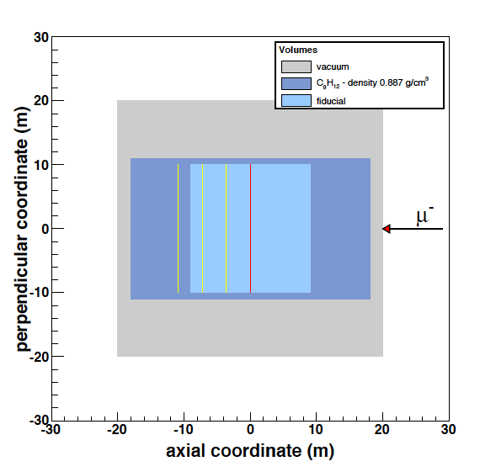

FIGURE 1. Cylindrical geometry used for the simulations, here shown for liquid scintillator.

The muon primaries are incident on the axis of the cylinder from large x-coordinate to small.

The one-directional neutron flux integrated over the detector cross section perpendicular

to the momentum of the muon primary is a good parameter to summarize the neutron production behavior over a wide range in neutron energies. This flux is plotted in Fig. 2, normalized to the number of generated primaries and the histogram bin widths. The fluxes compare favorably between the FLUKA and Geant4 simulations in general. The liquid scintillator and water seem to be within 30% over most of the energy range with the largest excursions near 100 MeV neutron energy. Other materials follow this general agreement in the region between 100 MeV and the highest energies plotted. Below

10 MeV CaCO3 has several resonant structures which are well tracked, indicating that implementation is successful in the nuclear physics regime. The case is similar for iron with the exception of a structure around 3-7 MeV which appears in the Geant4 simulation but not the FLUKA. Lead has a similar structure which is reproduced by FLUKA. Furthermore Geant4 begins to register dramatically less neutrons than FLUKA at 10 keV and 5 MeV. This is the largest discrepancy revealed so far and is not yet understood. ???

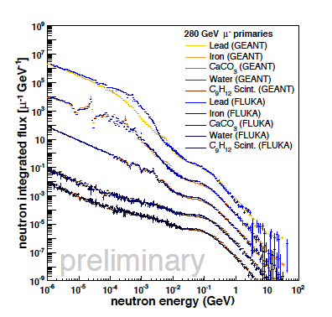

Figure 2. Integrated neutron fluxes across perpendicular planes for all materials down to neutron energy of 1 keV. Each material is scaled for plotting purposes: lead by 100, iron by 10−1, CaCO3 by 10−2, water by 10−3 and liquid scintillator by 10−4. The FLUKA simulations are shown in blue while the Geant4 simulations are shown in yellow/orange need new plot and corresponding description of colors.

FLUKA simulations are integrated over a plane at the geometrical center of the geometry whereas Geant4 simulations are averaged over the central plane plus three evenly spaced planes left of the central plane after the shower has fully developed.

The number of neutrons produced in any given event is tracked. Since the lateral distance is larger, almost all of the produced neutrons will remain inside the detection volume. Fig. 3 shows various properties of “captured” neutrons inside the fiducialized detector volume. A neutron is considered captured at the last tracked point of all neutrons with energies less than 3.1 eV. The energy 3.1 eV corresponds closely to a FLUKA low energy neutron group and is used for technical reasons. The capture time spectrum of Figure 3(a) shows that FLUKA produces slightly less neutrons than Geant4 and the capture time constant for FLUKA is XXX whereas the time constant for Geant4 is YYY. XXX and YYY were actually in the published paper!!

The discrepancy indicates a slight difference in the low energy neutron transport physics.

The other distributions look qualitatively similar, but there is slight normalization discrepancy, as it is often the case that the FLUKA curves are bounded below ?? what does this mean? the Geant4 curves. The discrepancy in the distributions of lateral distance is worse at shorter distances and lower muon primary energy. The largest discrepancy (factor of 2-4 per bin) is in the multiplicity distributions.

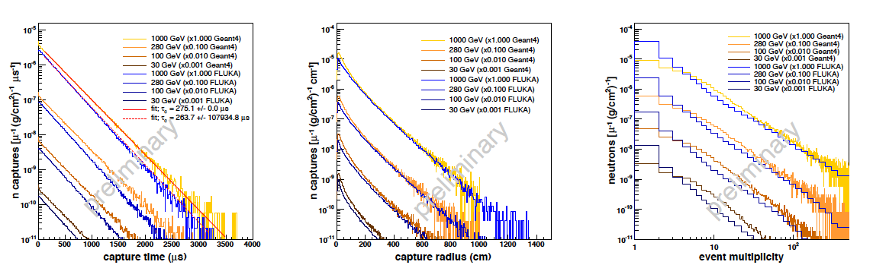

FIGURE 3. (a) Capture time distributions for all neutrons which capture with energies less than 3.1 eV. (b) Lateral distance distributions for captured neutrons. (c) Multiplicity distributions for captured neutrons.

*** Now comes the isotope part. There are also 2 possible routes to describe or introduce this section (blue and green). They should be merged and new information should be used to update it

The production of various isotopes in scintillator, along with a prediction from FLUKA, was recently reported by the KamLAND collaboration \cite{kamland}. Specifically, the production of 11C via the interaction 12C n 11C was found to be under-produced compared to data by a factor of ~ 2 \cite{kamland}. That particular channel accounts for nearly a third of the neutron production according to their result, and could well be a dominant cause of the neutron deficit in FLUKA. In this work, 11C production was counted from 260 GeV muons using the same method of counting used for neutrons, and found to be under-produced by a factor of ~3 compared to data. If that deficit is ameliorated in Geant4, the picture becomes complicated further: assuming the neutron yield at 260 GeV is increased enough to make up for the loss in 11C production compared to data, the yield from Geant4 increases from 3.6 x 10-4 to 4.2 x 10-4 n/muon/g/cm2, nearly a factor of two above KamLAND’s result of (2.8  0.3) x 10-4 n/muon/g/cm2. One should also note that KamLAND’s experimental neutron yield sits below the fit to the data. Three other isotopes, 7B, 12N, and 10C, are also produced along with neutrons. In the case of 7B, no experimental measurement exists but the predicted production is low compared to other neutron contributions. Both 12N and 10C are experimentally verified subdominant contributors compared to11C.

In order to understand these discrepancies, the same simple geometry is used to compare isotope production in the two codes and compare to the Borexino results.

Sarah’s results here. . Update and refer to the Borexino table?

The effect of a more realistic muon spectrum on the results was also studied, using as an example, the spectrum at a depth of 2100 m.w.e. (Soudan) and 4850 m.w.e. (Homestake).

The muon distributions are simple parameterizations (see section ??). Once these are applied to the same simple geometry…. Results here.

*II References*

[Geant4] S. Agostinelli, et al. (the Geant4 collaboration), Nuclear Instrumentation Methods A 506 (2003) 250; J. Allison, et al. (the Geant4 collaboration), IEEE Transactions on Nuclear Science 53 (2006) 270.

[FLUKA] A. Ferrari, P.R. Sala, A. Fassò, and J. Ranft, FLUKA: a multi-particle transport code, CERN-2005-10 (2005), INFN/TC_05/11, SLAC-R-773; G. Battistoni, et al. The FLUKA code: Description and benchmarking, American Institute of Physics Conference Proceedings 896 (2007) 31.

**III-B. Generating Muon spectra underground**

Every simulation begins with a distribution of muons at depth. To investigate the effect of muon distributions on experimental simulations, three methods were used to determine their initial energies and angular distributions. The first method is a general parameterization assuming a flat overburden. This method is easily adapted to a new location based on the depth of the lab being simulated, and is usually the first approximation for a simulation at a new depth.

Once the details of the topography are obtained for a particular lab, however, other methods which can deal with a non-flat overburden are preferable. An example of this is MUSUN/MUSIC, developed by V. Kudryavtsev. This method uses slant depths for the lab to calculate the muon energy and angular distributions at depth. These muons are then used as inputs to Geant4 or FLUKA simulations of the laboratory. Another method is to use Geant4 to propagate muons from the surface down to the lab depth, entering the topography directly into the geometry file of the simulation.

**III-B-1. Parameterization as a function of Depth for Flat Overburdens.**

The parameterization used for a flat overburden assumption was originally detailed in Cassiday, et al. [1] Both energy spectra and angular differential equations are given in that reference. The energy spectrum is given as



where Eμ is the muon energy after crossing the rock slant depth h (km.w.e.). The parameter A is a normalization constant, which can be obtained by calculating livetimes using known muon rates at the labs. The parameters used are consistent with Groom et al. [2], with b = 0.4/km.w.e, γμ = 3.77 and εμ = 693 GeV. The angular distribution was assumed to be a sec(θ) distribution, also consistent with both [1] and [2] for depths greater than 1.5 km.w.e.

The parameterization function of muon flux in Mei and Hime’s paper was obtained by fitting the measured fluxes at several underground laboratories (WIPP, Soudan, and SNOLAB) using this flat-overburden approximation. The depth for other underground laboratories in terms of a flat-overburden was determined using the fitted function and the measured muon fluxes. Rates were verified within factor of two. Energy spectra may differ by factor of two at low energies, but match well for muons of 100 GeV or higher. Muons of >100 GeV contributed more than 90% of total cavern neutron flux, so discrepancies at lower energies change the results by much less.

Muon energy spectra are compared for Soudan (2100 mwe), the 4850 level of Homestake, , and SNOLAB (??mwe) sites in Fig. [fig:muon-E-spectra]. These spectra are normalized for rate and their respective shapes are compared directly in Fig. [fig:muon-E-spectra-norm]. The energy spectra feature a crossover point near 170 GeV, providing a useful point for comparing relative proportions of high- and low-energy muons for various depth spectra. It should be noted that, for the range of this comparison, the low-energy spectral component varies from 64% of total (for Soudan) to 48% of total (for SNOLAB), while for Homestake it comprises 51% of total. The slope of the high-energy rolloff is also constant with power 3.77. The primary variation in muon-induced backgrounds is therefore expected to stem from differences in the overall muon flux for a various sites, rather than the change in spectral shape with depth. For this reason, the mean energy is often used to characterize the muon energy spectrum. The parameterizations give mean energies of XX, YY, and ZZ for Soudan, Homestake and SNOLAB respectively,



 Figure 1. Left: Muon energy spectra as a function of depth, taken from the parameterization described in [Mei2005]. Right: Same spectra normalized by area for comparison of shape.

The differential muon flux at 4850 level (4.4 km.w.e) at Homestake was measured by Cherry et al. [3] at early 80s. In order to characterize the muon flux as function of depth, the cosmic ray muon flux was measured in different depths of the Homestake Mine by using plastic scintillation counters [4]. The nearly vertical muon flux was obtained in three locations: on the surface (1.149 x 10-2 cm-2 s-1 sr-1), at the 800 ft level (2.67 x 10-6 cm-2 s-1 sr-1) and at the 2000 ft level (2.56 x 10-7 cm-2 s-1 sr-1). These fluxes agree well with model predictions [5]. The integrated muon fluxes for different depth are compared in Figure 2.

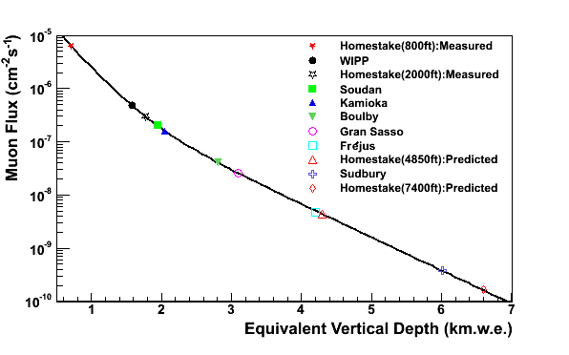

Figure 2. Integrated muon flux as a function of depth, compared against a flat-earth model. This model is used to extrapolate to the 4850 and 7400 ft level at Homestake.

*III-B-1 References*

1. G. L. Cassiday, J. W. Keuffel and J. A. Thompson, Phys. Rev. D 7, 2022 (1973)

2. Donalde E. Groom et al., Atomic Data and Nuclear Data Tables 78, 183 (2001)

3. M.L. Cherry, et al., Phys.Rev.D 27(1983)1444.

4. F.E. Gray, et al., NIMA 638(2011)63-66.

5. D.-M. Mei, A. Hime, Phys. Rev. D 73(2006)053004.

**III-B-2. Muon simulation code MUSUN for underground experiments**

MUSUN (MUon Simulations UNderground) is a muon generator useful for sampling muons in underground laboratories according to their energy spectrum and angular distribution. It uses the results of muon transport through matter carried out with MUSIC, convoluted with the muon energy spectrum and angular distribution at surface.

MUSIC takes a set of muons with initial energies from 102 - 107 GeV (~105 muons every Δlog E = 0.025) and propagates them through matter, creating a set of files to use for further processing. This is usually done by the code developer following instructions from a user about the rock composition and other possible specific features such as mountain profile in order to create a set of slant paths specific to the underground site and its overburden. The standard version of MUSUN works for vertical depths larger than 500 m.w.e. but other versions are available on request. There is no strict upper limit for the vertical depth, but the maximum slant depth should not exceed 15 km.w.e., which is where the neutrino-induced muon flux dominates over atmospheric muons.

After muon transport, the differential muon intensities underground,  are obtained by convoluting the energy distributions of the MUSIC muon files with the energy spectra of surface muons striking at different angles at the surface, using the equation:



where

 is the differential probability for a muon with an initial energy *Eμ*0 at the surface to have an energy *Eμ* at a depth *X* (obtained from muon transport using MUSIC), and

 is the muon spectrum at sea level at zenith angle *θ* * and

*θ* * is calculated from the zenith angle underground, *θ* , taking into account the curvature of the Earth.

To calculate the integral muon intensity needed for normalization, an integration of  over *dEμ* and *d*Ω is carried out.

The simplest version of MUSUN for a flat surface above the detector offers the choice of the power index of the muon energy spectrum at the surface and its normalization, the fraction of prompt muons, the vertical depth of the laboratory, the range of zenith and azimuthal angles, and the range of energies. No additional muon propagation is required for different options. Different types of rocks (rock compositions), however, require separate muon transport.

MUSUN is organized as a set of subroutines written in FORTRAN and called from the user-defined main program. ** Anthony describe his version inside Geant **

The first call is made to a subroutine that calculates differential and integrated muon intensities for a specific detector location. The intensity as a function of energy and zenith angle is stored in the computer memory as a two-dimensional array. Subsequent steps return muon parameters (energy and direction cosines) sampled from the stored energy and angular distributions. In the version for flat surface, azimuthal angle is sampled randomly between 0 and 2*π* since the assumption of the flat surface leads to the spherical symmetry. The muon charge is generated according to the ratio measured for high-energy muons: *μ* +*/μ* − = 1.3. When muons are subsequently used in multipurpose event generators such as Geant4 or FLUKA, it is useful to generate muons on the surface of a rectangular parallelepiped (cuboid) or a sphere with predefined dimensions. MUSUN offers these options as well. Muon parameters are written to disk and can be passed later to the event generators.

Several underground laboratories (LNGS at Gran Sasso, LSM at Modane and Homestake in South Dakota) are located under mountains with complex surface profiles. For these labs, special versions of the MUSUN code have been developed that take into account the slant depth distribution as seen from the underground laboratory. In these cases the depth is fixed (to the depth of a particular underground location) and cannot be changed at the stage of muon sampling. The muons are first sampled across the zenith angle *θ* and azimuthal angle *φ*, from the angular distribution determined by the convolution of muon transport and energy spectrum at the surface. Then the muon energy is sampled from the known energy spectra for specific slant depth at specific zenith angle. The total muon flux at this depth passing either through a unit cross-sectional area sphere or a cuboid with given dimensions, depending on the user’s choice, is returned and can be used for the normalization of simulations.

Differences in rock composition and density will introduce uncertainties in the input muon distribution. This dependence is difficult to parameterize analytically since the fractional change in muon intensity with density depends on the vertical depth, so a couple examples will illustrate the effect.

Consider a vertical depth of 1.5 km and the density of 2.70 g/cm3, resulting in a vertical overburden of 4050 hg/cm2 or m w.e. An uncertainty of 2% is typical when estimating an average density between an underground site and the surface, meaning that it can be in a range of 2.646 – 2.754 g/cm2. Consequently, the vertical overburden is in a range of 3969 – 4131 m w. e. resulting in a muon intensity variation of about ±(12-13)% from the value calculated for 4050 m.w.e. Muon intensities underground also depend on the rock composition. Changing mean values of *Z* and *A* for rock by 7%, may change the muon intensity by about 12% at a depth of 4 km w.e. Taken together, uncertainties in the rock density and composition may change the mean muon energy underground by about 3% at a vertical depth of 4 km.w.e.

Another potential uncertainty in the muon intensity and mean muon energy is linked to the parameterization of the muon spectra at the surface. Several underground experiments have found muon energy spectra steeper than that assumed in the Gaisser parameterization. This increase in the slope, and the associated change in the normalization constant, may change the muon flux by up to 10% depending on the depth. Luckily, the change at 4 km w. e. is only about 3-4% in muon flux and mean muon energy.

*III-B-2 References*

*V. A. Kudryavtsev, Muon simulation codes MUSIC and MUSUN for underground physics Computer Physics Communications 180 (2009) 339–346 (see also references therein)*

*V. A. Kudryavtsev et al. Simulations of muon-induced neutron flux at large depths underground, Nuclear Instruments and Methods in Physics Research A 505 (2003) 688–698*

**III-B-3. Studies of Muon Distributions at Soudan and Homestake**

The muon flux at 4850 ft level, Davis Cavern, Homestake Mine, is simulated by MUSUN [add ref to MUSUN from previous sections] and Geant4 simulation codes. The modified Gaisser’s parameterisation [1] is adopted for muon energy spectrum and angular distribution above ground:

$\frac{dI}{{dE}_{μ}dcosθ}=0.14{\left(\frac{E_{μ}}{GeV}\left(1+\frac{3.64GeV}{{E_{μ}\left[cosθ^{*}\right]}^{1.29}}\right)\right)}^{-2.7}\left[\frac{1}{1+\frac{1.1E_{μ}cosθ^{*}}{115GeV}}+\frac{0.054}{1+\frac{{1.1E_{μ}cosθ}^{*}}{850GeV}}\right]$ (1)

Muon energy and polar angle are sampled using Eq. (1) and generated uniformly on the surface of the earth. Both MUSUN and the new Geant4 application take account of the surface mountain profile, then transfer the surface muons down to the underground cavern. Figure 1 (a) shows the surface elevation map from the combination of a geographic survey [2] and satellite data [3], whereas map (b) is a closer look of the Homestake Mine area. The map (a) was adopted both by the Geant4 simulation and the MUSUN code where the regions outside the map are assumed to be flat. The present version of MUSUN for Homestake Mine uses one degree per bin for zenith and azimuthal angles to interpret the surface profile while the Geant4 application uses 5×5 m2 cells in an XY plane.

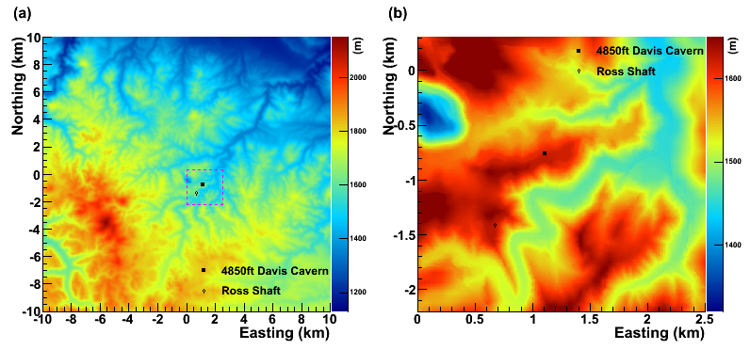

Figure 1. (Left): the surface mountain profile at Homestake Mine area from the satellite data and a geographic survey. (Right): a zoom-in look of Homestake Mine area.

There is over 1400 meters of rock overburden for the Davis Cavern. The composition of the rock sampled from Homestake Mine has been measured in reference [4] and a representative sample (No. 278-2) [5] is adopted in both simulations. The average rock density applied in Geant4 is 2.82 g/cm3 and 2.70 g/cm3. The current version of MUSUN for Homestake uses 2.70 g/cm3 but can easily be changed if required. The determination of the muons’ energy loss in the rocks is the prominent effect in the calculation.

Geant4 tracks muons step by step. All processes of muon energy loss are automatically registered and simulated by Geant4 itself. MUSIC (the muon transport code whose results are used in MUSUN) [add reference to MUSIC from the previous sections] also tracks and simulates individual muon and processes involved in muon energy loss. MUSIC, however, does not track secondary particles produced as a result of muon interactions. This makes the code run faster without loss of precision, since transport of secondary particles does not affect muon fluxes underground.

The absolute muon flux at the Davis Cavern is determined mainly by four factors, the surface mountain profile, the rock density and composition, the muon energy spectrum at sea level and muon interaction cross-sections. Due to the complexity of the geological structure, simulation with homogeneous rock of a single density and composition (which itself may not be very well determined) can only give an approximate value for the muon flux. The calculated total muon flux has to be normalized to measurement. In the GEANT4 simulation, 1×1013 muons (E>1TeV) are sampled using Eq. (1). They are then tracked from the surface down to the underground cavern. In order to obtain the absolute muon flux at the cavern, the live time of the total number of muons thrown is calculated by combining the surface area (20 km × 20 km) and the muon flux at the surface according the Eq. (1) which gives 6.8×10-7cm-2s-1 for Eμ>1TeV. The MUSUN simulation also calculates the flux using a similar algorithm, but normalized to 7.01×10-7cm-2s-1 (Eμ>1TeV) with a spherical surface at the sea level. The resulting absolute fluxes expected underground are listed in Table 1.

Add a column to Table 1 for the mean energy

|  |  |  |  |  |
| --- | --- | --- | --- | --- |
|  | Surface Map | Rock | Density (g/cm3) | Flux (cm-2s-1) |
| MUSUN | Map (a) | No.278-2 | 2.70 | 5.31 |
| GEANT4 | Map (a) | No.278-2 | 2.70 | 6.15 |
| Map (a) | No.278-2 | 2.82 | 4.85 |
| Mei & Hime | Flat surface | Standard Rock | 2.92 | 4.40 |

Table 1. The total Muon fluxes at Davis Cavern, Homestake Mine are   
 obtained using MUSUN, GEANT4 and Mei&Hime approaches.

The muon energy spectra obtained from these different approaches are compared to the parameterized muon spectra (e.g. Mei and Hime) in Figure 2.

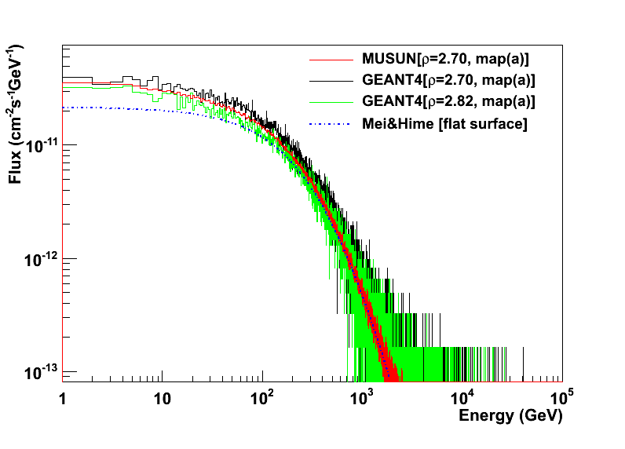

Figure 2. Muon energy spectrum at 4850 ft Davis Cavern estimated by MUSUN, GEANT4 and Mei&Hime prediction [6]. All the total fluxes are normalized to the surface muon flux shown in Eq. (1).

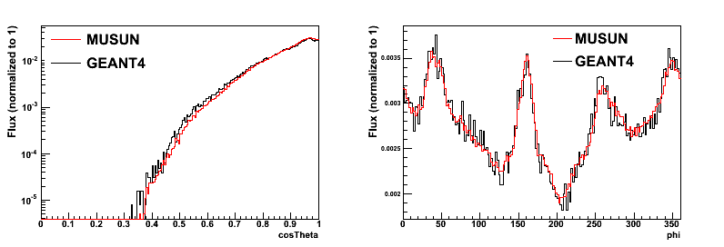

Figure 3. Comparison of muon angular distribution at 4850 ft Davis Cavern estimated by MUSUN and GEANT4. Both of the flux are normalized to 1. Azimuth is defined in the counterclockwise direction, where zero corresponds to East.

Comparison of the muon angular distributions obtained using MUSUN and Geant4 code is shown in Figure 3. The shapes match each other quite well despite differences in predicted flux. The total muon flux underground appears to be very sensitive to the average rock density assumed in the simulation. A 1% change in density causes a 5% change in the total flux. The muon energy spectrum at sea level can also affect the results. Instead of using Eq. (1), MUSUN starts with Gaisser’s formula with a spectral index of -2.77 and a normalization factor of 0.14×1.84 for muon energies above 1.5 TeV. This causes the calculated muon flux at the Davis Cavern to increase from 5.31e-9 cm-2s-1 to 5.51e-9 cm-2s-1.

The muon angular distribution is also sensitive to the surface mountain profile and the structure of penetrating rock. To understand these effects, we compare satellite data to an equivalent surface map. The surface map is derived by measuring the muon flux underground as a function of azimuth and zenith angle, and then projecting the results back to the surface, assuming a uniform rock density along the slant path. Soudan Underground Lab is used as the example, since slant paths were measured using muon data from the Soudan2 proton decay experiment [7] combined with MINOS measurements.[8] The resulting effective map yields figure 4 (left). This can be compared to figure 4 (right) which only takes the surface profile into account using satellite data [3]. The differences between the two are shown in figure 4 (bottom).

Two independent muon transport simulations were performed: MUSUN using the slant path data and GEANT4 using the satellite data. Lake Vermillion is the depression to the north of the east-west ridge shown in red. In general, the satellite data indicates a larger overburden and flattened profile. The satellite data over-estimates the overburden to the north by sensing only the water surface. To the south, it cannot account for variations in rock density. The effect on the angular muon distribution underground is presented in figure 5, showing that the flatter, deeper assumed overburden used in Geant4 results in an overall higher flux, but fewer vertical muons. The azimuthal angle is the most affected. Thus a 5% average elevation discrepancy (depending on the geographic details) was responsible for as much as a 15% discrepancy. This is due to the map, not to the simulation propagation, since GEANT4 and MUSUN agree when the maps are similar, as for Homestake.

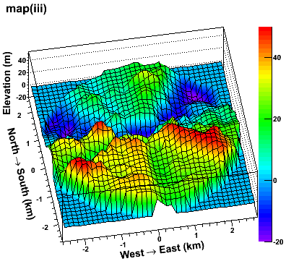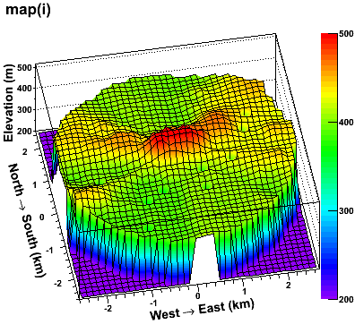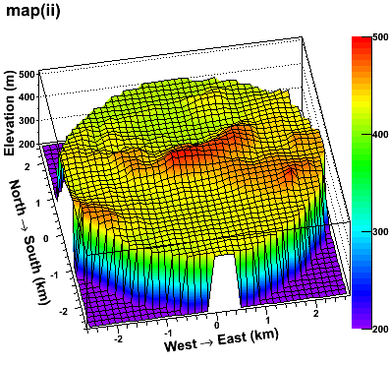

Figure 4. Left: the equivalent elevation map a­­round Soudan Mine area converted from the slant depths measured by MINOS experiment.   
Right: digitized elevation map around Soudan mine area from the satellite data. The central cavern is located at (0, 0, -217m).

Bottom: the elevation difference of two maps (satellite – slant path).

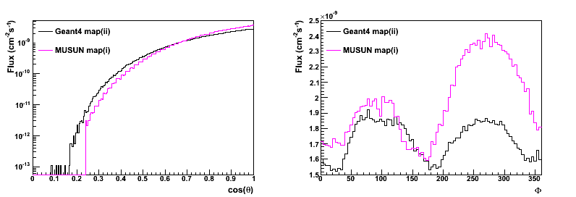

Figure 5. Comparison of the zenith (left) and azimuthal (right) muon angular distributions at the Soudan Lab between different map strategies. The left hump points north and the right hump points south.

[1] T. K. Gaisser and T. Stanev, “cosmic rays”, review of particle physics, Phys. Lett. B 592 (2004) 1.

[2] Geographic survey data are provided by SURF.

[3] <http://eros.usgs.gov/>

[4] B.T. Jordan, Geochemistry tectonic setting of the Yates unit of the Poorman Formation (DUSEL bedrock) and other northern Black Hills amphibolites: geological Society of Americal Abstracts with Programs 41 (7) (2009) 271

[5] D.-M. Mei et al., Astroparticle physics 34(2010)33-39

[6] D.-M. Mei, A. Hime, Phys. Rev. D 73(2006)053004

[7] <http://homepages.spa.umn.edu/~schubert/far/s2rock/vdepav.data>

[8] P. Adamson et al. Measurement of the atmospheric muon charge ratio at TeV energies with the MINOS detector. Phys Rev D76, 052003 (2007)

**III-B-4 Conclusion**

These three methods of calculating the muon distributions are very similar. A direct comparison is shown in figure ??. While the parameterizations reveal general features of the muon spectrum as a function of depth, MUSUN and Geant4 are flexible enough to account for a non-flat overburden using satellite data. However, actual measurements of muon angular distributions underground can still disagree with the resulting simulation due to non-uniform densities and water features.

Plot MUSUN vs Groom vs Geant4 at Soudan& Homestake) **(Angie, Chao)**

The shape of the energy distribution is somewhat different, with the parameterization Describe the main uncertainties, including statistics used, Fortran compiler, whether mean energy is a relevant parameter.

**III-C. Muon-induced Secondaries underground**

Muon spectra at depth can be determined to varying degrees of accuracy by a number of methods, as shown above. A good characterization of the secondary particles produced by these muons is much more complicated. An early attempt to parameterize the resulting neutron production is found in reference (cite Mei&Hime) in which a global fit to the differential neutron energy spectrum for various underground sites was performed. The parameterization took into account production mechanisms including neutron production through muon captures, direct muon spallation, and muon-induced electromagnetic showers and nuclear showers. In the parameterization function, the exponential component represents soft neutrons produced mainly from muon capture and muon-induced electromagnetic showers while the power law component describes hard neutrons produced primarily through muon-induced nuclear showers.

** DongMing please give short paragraph describing the Mei and Hime methodogy.

This method neglects the correlation of secondary particles and multiple neutron production, as well as the considerable additional showering produced by the same muon as it encounters experimental structures and the floor of the cavern. Time-consuming Monte Carlos of all the secondaries produced in the last 4 ?? meters of rock before the muon enters the cavern is essential to an accurate background estimate.

** Is there an easy way to demonstrate this by citing data (Boulby?)?? Vitaly

All simulations described in the next section track every secondary particle as it interacts with the rock, as well as additional interactions with the experimental apparatus. Albedo effects mean that even the detector location and size of the cavern will affect the result. The spectra and multiplicities of neutrons and gammas generated from muon interactions in cavern rock can be plotted as a function of muon energy. Figure 2 shows the result for three sites of interest: Soudan, Homestake 4850, and SNOLAB.

Need to generate this figure for Soudan, Homestake and SNOLAB – use parameterization.

Figure 2: Neutron multiplicity (left) and kinetic energy (right) for several selected muon energy ranges.

Monte Carlo results indicate that the change in neutron and gamma generation with muon energy is dominated by an increase in average multiplicity per muon, while the energy spectra for individual particles is not significantly shifted. This suggests no significant change in spectral shape between depths. The significant change in backgrounds comes from the change in multiplicity with muon energy, which acts as a multiplier with the increase in muon flux for a given depth. The plots which demonstrate this conclusion are shown below.



Figure 3: Average number of neutrons (left) and gammas (right) detected in the simulation cavern per detected muon, as a function of muon energy.



Figure 4: Gamma energy spectra (left) and multiplicity (right) for several selected muon energy ranges.

Top of Form

Bottom of Form

**IV Implications for Dark Matter experiments at Homestake 4850**

**IV-A** **Geometry of the Generic Technologies**

To determine if the 4300 mwe depth is suitable for siting a ton-scale dark matter experiment, we compare three major technologies, liquid xenon (LXe), liquid argon (LAr), and solid germanium (Ge), with respect to their ability to recognize a single nuclear recoil caused by a WIMP and distinguish it from cosmogenic backgrounds. In order to identify differences based only on the technology, the overburden and shield must be as similar as possible. Each is housed inside a cylindrical water shield, 12 m in height and 12 m in diameter. The individual detectors have realistic cryostats that differ, depending on the technology, but in general the active material is a contained within a 2 m diameter cylinder located at the center of the shield, resulting in at least a 5 m thick shield of hydrogenous material. Since such a shield can be instrumented to veto muons at ~100% efficiency, all simulated muons which pass through the shield are tagged. However, additional veto power provided by partial detection of neutrons is neglected in this comparison, since it is expected to provide the same rejection power by all technologies.

The LXe detector consists of a 3 mm thick titanium cylinder of 2 m diameter and 2m height, filled with liquid xenon. While the active material for the LAr detector is also in a 2 m x 2 m cylinder, the vessel is made of 1 cm acrylic on the sides with a 0.5 cm PMT glass top and bottom. It is then enclosed in two additional 2.5 mm thick stainless steel cylinders of 3 m x 3 m and 4 m x 4 m respectively, in which liquid scintillator can provide additional background rejection. In this study, however, it acts simply as shielding material. The Ge array is arranged in 10 towers of 30 individual detectors. Each detector is a 5 cm thick germanium crystal, 15.24 cm in diameter. They sit inside a vacuum, enclosed in a 3 cm thick copper cryostat, which is itself surrounded by a 20 cm thick layer of polyurethane inside a 2.2 diameter stainless steel vessel with 1 cm thick walls. Figure ?? shows the Geant4 geometries used for this study.

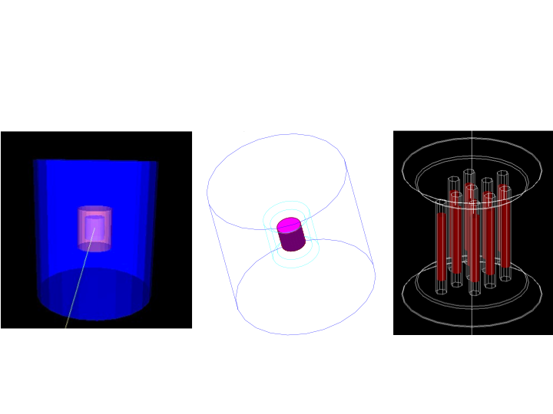

Figure ?? The three simple geometries used to compare ton-scale LXe (left), LAr (center), and Ge (right) dark matter experiments at 4300 mwe. Each target takes up roughly the same volume and shares the same 5m thick water shield, but there are differences in the realization of technology and interior vessel choices. The water shield is shown for the noble liquids, whereas the Ge figure concentrates on the detail of the detector itself.

To avoid uncertainties induced by different choices of muon generation and secondary particle accounting, we chose to use the same set of Homestake MUSUN-generated muons for all three simulations, with a mean muon energy of 219 NEW VALUE!! GeV and a spectrum corresponding to the ?? curve in figure ?? The resulting muons are propagated through 7 m of rock using Geant4 v4.9.5 P02 (with “Shielding” physics list) and then enter a 10 m x 10 m x 10 m cavern with the water shield at the center. To get even one WIMP-like single nuclear recoil in any of the detectors takes at least 8 ?? live years of simulated muons. To put any sort of error bars on the resulting small statistical sample requires at least a factor of ten more livetime.

Table of nuclear recoils, giving a definition of the cuts decided upon

This is just a table from the wiki basically.

**IV-B** Veto strategies and resulting reduction in background

**IV-C** Singles cuts, energy deposition, Detector specific issues (LAr v Ge v LXe)

**IV-D** Predicted event rates and sensitivity reach

Top of Form

Bottom of Form

**V. Scaling to different depths**

**V-A Soudan study**

Intro to general effects of going shallow: Soudan Underground Laboratory is at a depth of 2.0 km.w.e., a factor of 1/2.2 that of Homestake 4850. The total muon flux at Soudan is then a factor of 50 higher. However, the expected neutron flux scaling is lower than a factor of 50 due to the lower average muon energy at Soudan. Convolving the Soudan and Homestake muon energy spectra with the typical multiplicity per muon energy, the neutron flux at Soudan is reduced by a factor of 0.89 (*work in progress* – probably too high) from the raw muon flux scaling. This leaves a factor of 45 total increase.

Compare Sims to CDMS Soudan full MC (plots from CDMS and Angie)

Results from the Neutron Multiplicity Meter (Melinda)

**V-B. Scale spectra for deeper site (SNOLab)**

Intro to general effects of going deep, with examples from SNOLAB: For facilities deeper than Homestake, spectral shape varies little, as described above. The overall SNOLAB flux is a factor 1/12 below the Homestake flux. The increase in average muon energy results in a negligible factor of 1.03 (*work in progress*) in expected flux.

**V-C Parameterization and Scaling Scheme to deal with Depth**

Use this to discuss advantages of depth and how shallow you can go.

**VI. Conclusion**

What did we learn about Depth and Uncertainties remaining? List and prioritize needs for the future - what bkgd experiments and sims are needed