**X. Muon-induced neutrons in liquid scintillator**

The muon-induced neutron yield has been measured at various depths at underground sites over the last 60 years. Early experiments were carried out in Russia (USSR) and the experimental results were preceded by the theoretical work of G. T. Zatsepin and O. G. Ryazhskaya in 1965 [1] (who also led the measurements). Their calculations predicted the muon-induced neutron yield to be a function of mean muon energy and to follow a simple power law with the normalization obtained from fits to experimental data. The interest in muon-induced backgrounds and the neutron yield at that time was motivated by the first atmospheric and solar neutrino experiments [2].

Early experimental data for the neutron yield has been reported for liquid scintillator although the experimental groups have not proven that the observed neutrons had been produced mainly in the scintillator. The experimental data are shown as a function of mean muon energy in Figure X together with the early prediction derived from [1] given by the thin black line for both linear (left) and double logarithmic (right) scale. As pointed out in section ??, the older experimental results which are shown by the solid black symbols require careful interpretation. No detailed MC simulations were available to aid the data analysis at the time and to convert the measured rate of captured neutrons into the neutron production rate in a specific material (scintillator). This is particularly important since the data was obtained either with relatively small detectors and/or with large detectors of mixed target materials. The lack of proper simulation tools also impacts the quoted mean muon energies. The unmodified and originally reported values for mean muon energy and neutron yield are shown in Figure X.

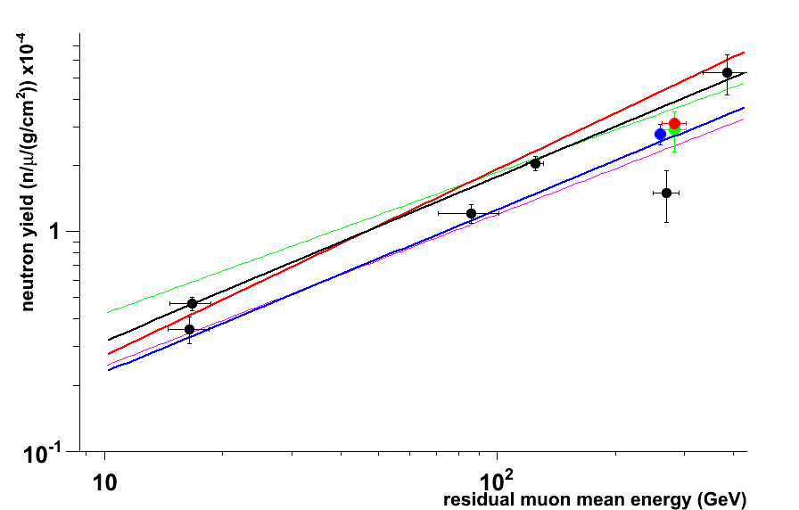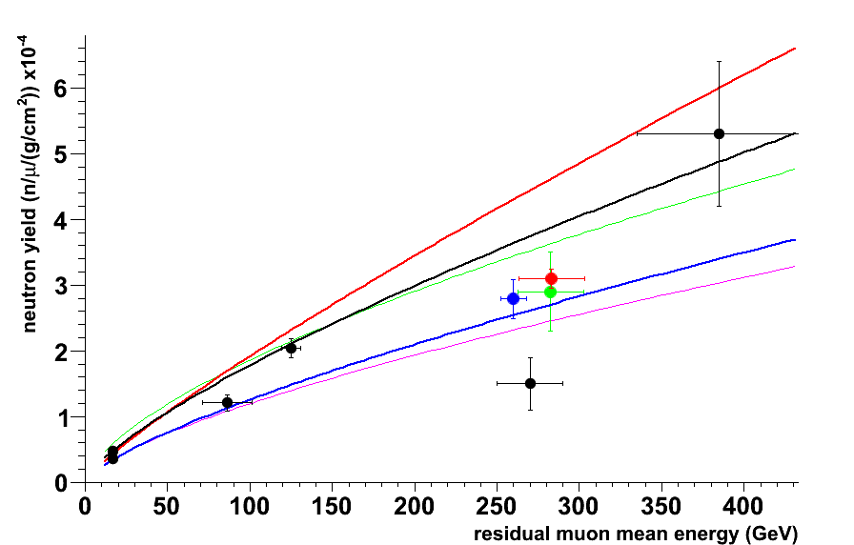

Figure X: Muon-induced cosmogenic neutron yield. The old experimental data are given by the solid black symbols. Sorted by increasing mean muon energy (in GeV) they are: Boehm et al (16.5) [3], Bezrukov et al (16.7, 86) [4], Enikeev et al (125) [5], Aglietta et al (270) [6] and Aglietta et al (385) [7]. The new results from KamLAND [8] (solid blue symbol), LVD [9] (solid green symbol) and Borexino [10] (solid red symbol) are also shown. The experimental values are compared to predictions for the neutron yield derived by G. T. Zatsepin and O. G. Ryazhskaya 1965 [1] (thin black line normalized to the experimental data known at that time), Wang et al 2001 [11] (thick blue line), Mei & Hime 2006 [12] (thick red line), Geant4 4.9.5p01 (thin green line) and FLUKA 2011.2.17 [13] (thin purple line).

Further, three modern results obtained at the Kamioka mine by the KamLAND experiment (blue symbol) and at LNGS by the LVD (green symbol) and Borexino (red symbol) experiments are also available. These new results are based on large detectors and the data analysis is supported by detailed MC simulations. In particular, the exceptional efficiency to record more than 80% of all cosmogenic neutron captures in coincidence with muon events in a large, ultra pure and homogeneous detection volume greatly reduce systematic uncertainties for the Borexino result.

Also shown in Figure X are two frequently quoted parameterizations proposed to describe the cosmogenic neutron production yield as a function of mean muon energy. A simple power law behavior with Nn=4.14∙Eμ0.74∙10-6 n/(μ g/cm2) was obtained by making use of the FLUKA simulation program (Wang et al, 2001 [11]) which is shown by the thick blue curve. The thick red line corresponds to Nμ=3.824∙Eμ0.849∙10-6 n/(μ g/cm2) which was derived from a fit to the somewhat modified old experimental data (Mei & Hime, 2006 [12]). Other parameterization based on FLUKA and GEANT4 simulations have also been proposed but are not included on Figure X (see, for instance, [14]). Finally, the results of simulating the cosmogenic muon-induced neutron yield with current versions of the Geant4 (thin green line) and FLUKA (thin purple line) simulation tools in context of the AARM project [13] are also given.

More details on individual experiments are given in Section ???

A number of experiments have recently reported the neutron production rate in iron [9] and lead [15,16,17]. They have been carried out at large depths underground with corresponding mean muon energies within the narrow range of 260-300 GeV so no energy dependence can be extracted from these measurements. They are, however, very useful in predicting the neutron background in current and future high-sensitivity rare event searches.

[1] G. T. Zatsepin and O. G. Ryazhskaya, Proc. Of the 9th ICRC, Vol 3, London, 1966

Izv. Akad. Nauk SSSR, Ser. Fiz. 29, 1965

[2] Kolar Gold Fields

East Rand Propriatory Mine

Davis experiment, Homestake

[3] “Neutron production by cosmic-ray muons at shallow depth”,

F. Boehm et al, Phys.Rev. D 62, p 092005, 2000, arXiv:hep-ex/000601

[4] “Investigation of Depth-Intensity Curve of Nuclear Events Induced by Muons”,

L. B. Bezrukov et al, Proc. of the 13th ICRC, Denver, Vol 3, 1947

Yad. Fiz. 17, 98 1973 (Sov. J. Nucl. Phys. 17, 51 1973)

[5] “Hadrons generated by cosmic-ray muon underground”,

R. I. Enikeev et al., Yad Fiz. 46, 1492 1987 (Sov. J. Nucl. Phys. 46, 883 1987)

“Hadrons and Other Secondaries Generated by Cosmic-ray Muons Underground”,

F. F. Khalchukov et al, Il Nuovo Cimento, Vol 18C, N.5, 1995

[6] “Measurement of the Neutron Flux Produced by Cosmic-Ray Muons with LVD at Gran Sasso”,

M. Aglietta et al, Proc. of the 26th ICRC, Salt Lake City, Vol 2, 1999, arXiv:hep-ex/9905047

[7] “Neutron Flux Generated by Cosmic-Ray Muons at 5200 hg/cm2 s.r. Underground.

Depth-Neutron Intensity Curve.”

M. Aglietta et al, Il Nuovo Cimento, Vol 12C, N.4, 1989

[8] "Production of radioactive isotopes through cosmic muon spallation in KamLAND",

S. Abe et al, Phys. Rev. C 81, arXiv:hep-ex/0907.0066, 2010

[9] "Measurement of the muon-induced neutron yield in liquid scintillator and iron at LNGS with

the LVD experiment",

R. Persiani, M. Garbini, G. Sartorelli, M. Selvi for the LVD Collaboration,

poster at LRT (LNGS), 2013 - paper in preparation

[10] "Cosmogenic Backgrounds in Borexino at 3800 m water-equivalent depth",

G. Bellini and others, accepted for JCAP, arXiv:1304.7381, 2013

[11] "Predicting neutron production from cosmic-ray muons",

Y. F. Wang and V. Balic and G. Gratta and A. Fass`o and S. Roesler and A. Ferrari,

Phys. Rev. D 64, 013012, 2001

[12] "Muon-induced background study for underground laboratories",

Mei, D.-M. and Hime, A.,

Phys. Rev. D 73, 5, 053004, 2006

[13]

A. Villano et al, Proc. LRT 2013, submitted

[14] “Simulations of muon-induced neutron flux at large depths underground”,

V. A. Kudryavtsev et al., Nuclear Instruments and Methods in Physics Research A 505 (2003) 688–698.

[15] “Measurements of neutrons produced by high-energy muons at the Boulby

Underground Laboratory”, H. Araujo et al. Astroparticle Physics 29 (2008) 471–481

[16] “Measurement and simulation of the muon-induced neutron yield in lead”,

L. Reichhart et al. , Astropartifcle Physics, 47 (2013) 67–76

[17] V. Kozlov for the EDELWEISS Collaboration. Poster at the LRT2013 Workshop (LNGS, Italy, April 2013).

K. Eitel for the EDELWEISS Collaboration. 12th Intern. Conf. on Topics in Astroparticle and Underground Physics (TAUP 2011). IOP Publishing. Journal of Physics: Conference Series **375** (2012) 012016