Dear Working Group Leader:

In our final Solicitation 1 paper, there will be a chart of the yearly screening demands in the US. A first draft of this (see below) was assembled by the subgroup on Low Background Facilities and compiled by Kevin Lesko. The downturn after 2008 simply reflects our concentration on near term experiments. To improve this chart we are asking each working group to complete the following list of current and future experiments in your area, including any next generation experiment(s) likely to be at DUSEL. For geo/bio working groups, these may be applications requiring radiometric analysis, rather than named experiments Concentrate on those that are likely to require US facilities for screening, i.e. collaborations that have a US component. Following that, the working group leaders should contact the appropriate members of their group and/or the PI’s of the relevant experiments and have them fill out this survey. It is part of the infrastructure matrix which all working groups are required to complete by February 6. Please collect the surveys in your own working group as they may be relevant to your infrastructure matrix, but also have all completed forms returned to Prisca and Harry by 2-6-05.
prisca@physics.umn.edu harry.miley@pnl.gov

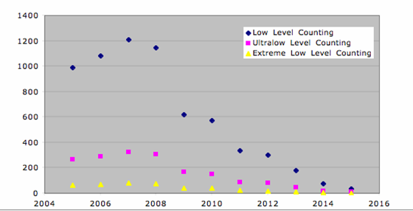
Number of Samples screened per year

Working Groups

1. low energy neutrino: Borexino, CLEAN, Cuore
2. double beta decay: Majorana, MOON, EXO
3. LBL neutrino:
4. p-decay/atm nu: UNO
5. dark matter: XENON, CDMS, SuperCDMS, DUSEL LAr/Xe, DUSEL Cryo, COUPP
6. Nuclear astrophysics: KamLAND
7. Coupled Processes: dating
8. Rock Mechanics
9. Applications
10. Geomicrobiology: tracer uptake
11. Microbial bio and evolution

SCREENING SURVEY

Make a list of materials to be screened.
For each material, include this information in the following order:
- Material description (size, sol/liq/gas…)
- Expected screening technique (if known, eg. α, β, γ or HPGe, ICPMS, NAA…..)
- Estimated samples/year (including replicates)
- contaminant screened or isotope(s) analyzed
- sensitivity desired (ppb or Bq/kg)
- energy range (e.g. for HPGe counting)
- underground sample preparation (if required)
- special handling or security (if required)

PROTOTYPE SURVEY

If you need underground space for a prototype or plan R&D on new screening techniques please fill out this section:
- Function of Prototype or R&D module
- Size of prototype/detector and description
- What depth and/or shielding required (specify type of radiation and level of reduction)
- What shared infrastructure would be helpful
(a) cryogen handling or purification
(b) radon reduction
(c) copper/lead/poly shielding
(d) water shielding
(e) active muon veto

