Introduction
The Soudan Underground Laboratory is a 710 m (2090 mwe) deep laboratory in northern Minnesota, which has been operated by the University of Minnesota since 1980. It includes two experimental halls, each 15 m wide by 16 m high. The Cryogenic Dark Matter Search (CDMS II) occupies the 70 m long West Hall and the 5,500 ton MINOS Far Detector is located in the 82 m East Hall. The Soudan 2 Proton Decay experiment [1] stopped data-taking in 2001 and its kiloton calorimeter was finally removed from the back section of the West Hall in 2005, leaving its muon veto shield intact. This created a 13 m x 10 m x 40 m lab space located 2341 ft deep (2090 m.w.e.) surrounded by more than a thousand gas proportional tubes lining the walls, ceiling and floor. The veto tubes on the floor were removed since there is only ~1 upward-going muon per week and lots of gaps due to support structures. All the veto panels were pressure tested and run to HV under gas. Signals were observed from the preamps and noisy or dead channels were repaired. A new gas handling system was built, including gas checkers to monitor oxygen content in the input gas.
In order to create a multi-user facility which could take advantage of a muon-shielded room, the CAMAC-based trigger logic was replaced by a PC-based system with custom electronics based on CPLDs, which then provides a database (GPS-based time stamp and track location) of every entering muon. It thus can be used as an offline muon veto for any experiment or screening device located inside its coverage and even has sensitivity to neutrons whose muons do not enter the cavern, via accompanying charged shower products at the cavern wall. In addition, as a large-area, moderate-granularity muon and electromagnetic shower fragment detector, it can be used to understand underground showers in general, and benchmark cosmogenic Monte Carlo simulations.
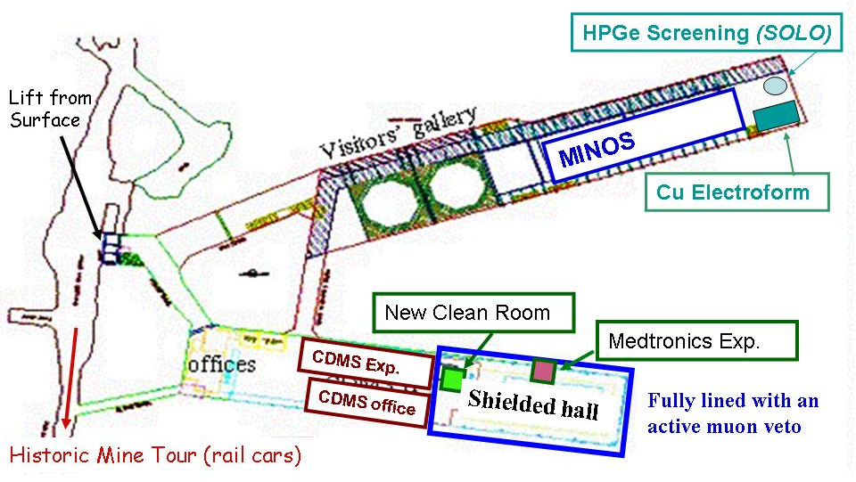

Figure 1. The layout of the Soudan Underground Laboratory, showing the location of the new muon-shielded experimental hall in relation to the running experiments. Experiments and screeners operating inside the shield are also shown.

Proportional Tubes
The veto shield panels are constructed from sheets of nested aluminum modules. Each module is an extruded form in which eight hexagonal wire chambers are arranged as a double layer of honeycomb cross section as shown in figure 2. The aluminum walls are ?? thick. Each wire chamber channel is ?? wide from flat-to-flat (inner dimension) and contains a single gold wire of ?? diameter strung down the center. The outer casing is grounded and the sense wire is held at an operating voltage between 2100 – 2500 volts, with a resulting gas gain of ?? The four wires of each layer are connected in series. Each module is thus a 21 cm wide double layer tube with one readout channel per layer. Most of the tubes are 7 m long, but shorter tubes are used to shadow openings or cover gaps. They filled with 90% - 10% Ar-CO₂ at 1.12 bar.

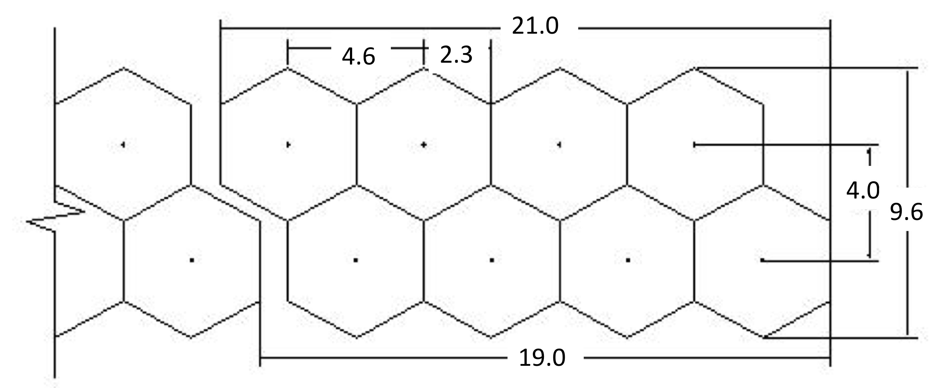

Figure 2. Cross-section of the eight gas proportional chambers which compose one veto module or “tube”.

The end of each tube is connected to a two-channel preamplifier board, which reads out two layers independently. When a particle passes through the chamber, the resulting current ?? pulse is capacitively coupled to a ?? to produce a ?? signal in the preamp board. After amplification (how much??), if the signal is above the fixed threshold (?? mV) comparator, a one-shot creates a 1.2 μsec TTL pulse, which is then converted to TTL? differential signal and routed to separate readout electronics via 64-pin twisted pair ribbon cable. Each 64-pin cable is capable of accommodating 32 channels (16 tubes) of data. The preamp cards are also responsible for distributing the high voltage to the wire chambers. Both low voltage and high voltage are daisy-chained along the tubes and from module to module to form larger units called panels. Each wall panel has 50 tubes, so each wall panel requires slightly more than three full cables. The ceiling panels each have 166 tubes and require ten full and one partial cable each.

The entire shield is divided into four geographical sections and feeds into four readout and power distribution stations arranged around the room. Low voltage (+- 5, -7, +12??) is supplied to the preamp cards via a breakout boxes with adjustable and fuse-protected channels for each panel group. The breakout boxes are fed by one +5V and one -7V power supply per station. (??) The high voltage for the tubes (0 - 2500 V) is provided by +5 kV Bertan supplies designed for use with proportional wire chambers. Each section is powered by one HV supply which passes through a distribution box to allow individual panels to be powered separately.

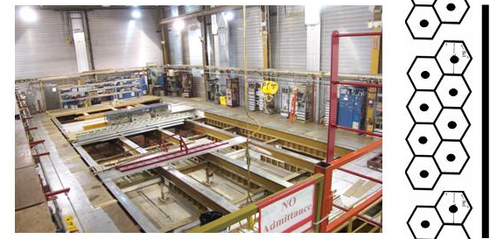
Figure 3. A picture of the Soudan Low Background Counting Facility’s muon-shielded experimental hall before installation of experiments and screeners. Aluminum proportional tubes line the walls and ceiling. A panel is built up by vertically stacking the 8-channel modules as shown in the cross section to the right.
The veto shield covers the entire surface of the ceiling and walls of the hall with the exception of the north access door, which is shadowed by a wall of tubes set ?? meters inside the hall. The majority of the shield is constructed of panels of 7 m long tubes oriented horizontally around the walls and running east-west ?? along the ceiling. The wall panels, 12 in total, each contain 50 tubes while each of the 2 ceiling panels contains 166 tubes. Figure 3 provides a view of the shielded room looking south from in front of the north shadow wall. The ceiling extends beyond the walls by ?? cm? to provide gap coverage on the wall/ceiling interface. The gaps between adjacent wall panels are covered by tubes aligned vertically to produce a narrow hanging panel on a sliding bracket. These overlap walls can be slid aside to provide access to the tube ends behind. Since the main experiments using the shield are located in the north end of the hall, as is the screening clean room, the ceiling directly above is covered by a second layer of tubes which are arranged at right angles to the primary set of tubes on the ceiling, thus providing four coincident layers on the roof. There are a sufficient number of spare tubes to implement this across most of the ceiling in the future if warranted.

Gas Handling System

The gas handling and control system was originally designed at Oxford University for the Soudan 2 proton calorimeter. The gas rack itself with the diagram on its front is shown in figure 4. Those parts required for the operation of the veto shield were left in place. Each tube is filled with a 90/10 Ar/CO₂ gas mixture at several hundred mbar above atmospheric pressure. The circulation path of the gas through the tubes starts with the supply manifold which distributes the gas through ½” to 1” copper pipes to the individual panels. The individual tubes are daisy chained in groups of four. Gas enters the first tube from the supply pipe and leaves the fourth tube via a return pipe. A restrictor, consisting of a pipe with a small needle running through it, is placed between the supply pipe and the first tube in order to ensure an even flow of gas to all the tubes in the chain. It also prevents sudden leaks in one section from degrading the gas in another. The return pipes direct the gas to the return manifold.

From the return manifold the circulation pump moves the gas from the tubes through a catalytic converter to remove oxygen that may have leaked into the gas stream. This oxygen purge step requires ~1000 ppm H₂ in the gas stream. A mixture of the basic 90/10 Ar/CO₂ with 4% H₂ is injected before the catalytic converter for this purpose. The hydrogen and oxygen levels are monitored by a set of sensors both before and after the converter, to determine the hydrogen levels and to log the efficiency of the conversion. The oxygen sensors will automatically stop the circulation pump if oxygen levels spike, in order to prevent a major leak from contaminating the entire system. This is crucial, since it can take up to four weeks to purge a contaminated panel completely. After the gas passes through the catalytic converter it travels back to the supply manifold.

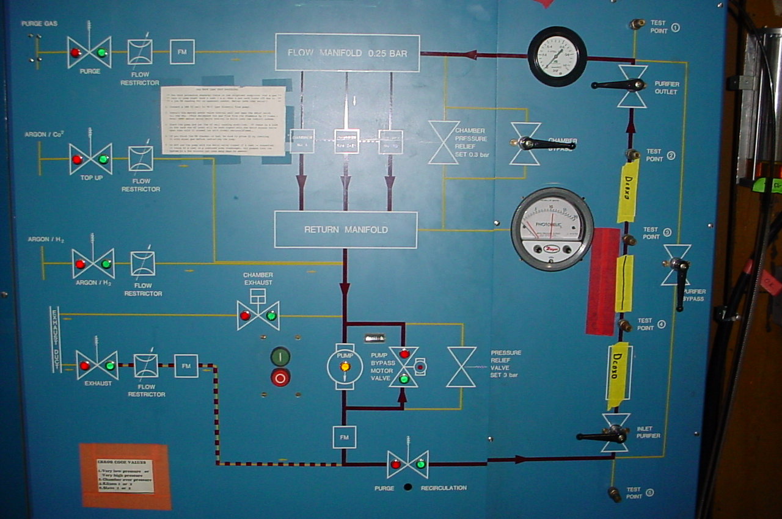

Figure 5. Photo of the gas rack which circulates the gas through the system and removes oxygen. The diagram on the front gives a good overview of the gas system. *** Need a flow chart instead of photo**

Make up gas of the same 90/10 Ar/CO₂ composition is provided by a gas mixer which starts from bulk argon and carbon dioxide. The mixer uses a differential regulator to equalize the pressure of the constituent gases and then combines the gasses through by passing them through equal area tubes, where the number dedicated to Ar is approximately nine times larger than the number dedicated to CO₂. The actual number of tubes differs from a straight 9:1 ratio because ***?? Explain how many there actually are and how you figure out how many. **** The mixer creates the gas in batches and stores it in a large tank for use in the shield; these large batches help maintain batch consistency. Make-up gas is introduced anytime the bulk mix tank falls below the preset tube low pressure threshold. It is injected directly into the supply manifold as necessary to maintain the proper pressure in the manifold.
*** More detail on the mixer? ***

Gas flow and pressure is monitored and controlled using a set of sensors, which we replaced and calibrated in the lab. ** give names and manufacturers of all sensors. Describe Flow sensor function and its calibration *** Oxygen and hydrogen sensors in the supply and return manifold control the amount of hydrogen that is injected into the system in order to suppress all the oxygen in the gas. ** any more on the gas sensors?? ** The pressure sensors in the manifolds are used to maintain the flow of gas through the system. Pressure above ?? ** any other trip?*** causes the pump bypass to kick in, removing the circulation pump from the circuit. When the total system pressure drops below the set threshold of about 100+ mbars above atmosphere, makeup gas is automatically valved in from the mixing tank. There is a built in mechanical safety switch which prevents the pressure differential between supply and return manifold from exceeding 0.3 bars. Running at a slight overpressure keeps oxygen out of small leaks, without having the complications associated with high pressure operation.

This system was supplemented by a LabView computer monitoring and control interface. The new interface monitors all the quantities available to the old hardware control system, as well as the temperature of the gas leaving and entering the pumps, the status of the main control valve, gas purity sensors, and a new sensor that monitors the percentage CO₂ in the gas coming from the mixer. The interface logs these values as well as providing new control options. *** specify new options – like user intervention? ***. The hydrogen levels are now controlled by the computer, rather than *** how was it done before? *** allowing more dynamic control over hydrogen levels. The pressure controls are still ??? ** . The interface can stop the circulation pumps or valve off the makeup gas mixer input if it detects a drop in gas quality below acceptable levels. Improvements introduced by the new controller interface thus include additional safety features and functionality, a user-friendly virtual panel interface (see figure 6), standardized software access to the hardware, and remote control and monitoring.

*** need 2 good figures side by side

Figure 6 – Screen shot of the LabView panels to the new gas system control interface.

Custom Readout Electronics and Data Acquisition
The original Soudan2 CAMAC-VAX data acquisition system (DAQ) was completely removed and we designed a modern flexible DAQ using custom front end boards and a LabView interface running on distributed PCs. In order to accommodate multiple users, the design is based on XC9572 CPLDs (complex programmable logic devices). These devices allow us to customize the shield functionality and trigger mode simply by reprogramming the chips. The system is composed of two basic functional blocks, which are realized in two different types of boards: a signal conditioning board called the Pulse Stretcher and a serial readout and timing card called the Multiplexer or MUX card. A custom crate was designed such that the MUX is mounted as a backplane and 8 stretcher boards slide into the crate slots and plug into the MUX. A photo of the set up is shown in figure 7.
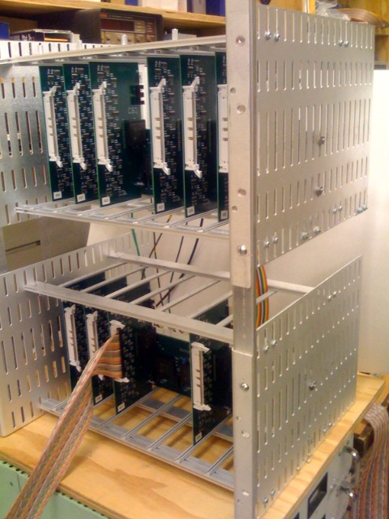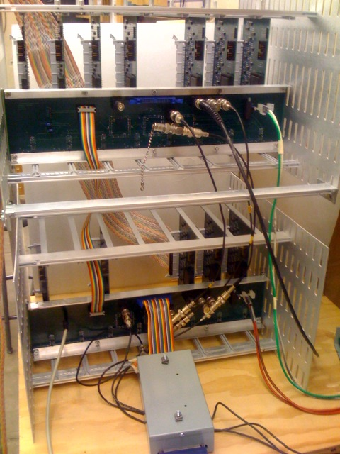
Figure 7. Photo of the front end electronics and custom crate
The pulse stretcher boards each accept a single 64 pin (32 channel) signal cable and convert the signals from differential pulses into TTL levels. The TTL level signals are then stretched from 1.2μs to 4μs with one-shots, such that all signals coming from the same event will properly overlap in the trigger and MUX timing. The pulse width is determined by timing delay in different length signal cables, propagation delay in the electronics, and the several μs drift time differences due to particle path variations in the tubes themselves. An earlier version of the DAQ missed about ~0.5% of events, so the original one-shots were replaced with a re-triggerable type. The stretched pulses then pass to a Xilinx XC9572 CPLD where all of the trigger logic is implemented. Implementing the logic in the CPLD allows us to implement a wide and dynamic array of trigger choices. The first step in multiplexing is also done within the stretcher CPLD in order to reduce the number of data lines transferred to the MUX. ** explain more about the tye of multiplexing and also how the data latches work. **
Signals from the 8 pulse stretchers then go to two CPLDs on the MUX board. There they undergo the second step of multiplexing ** explain** and add a time stamp to the event. The third CPLD serves as the controller for the data read. It concatenates the triggers from each of the eight pulse stretchers and then initiates the read by sending out multiplexer control bits to the stretchers, its own multiplexer CPLDs, and to the National Instruments 6534 IO?? card after a programmable delay. The NI 6534 is used to read the data into the computer. ** here describe the 6534 ** When prompted by the read control CPLD in the MUX, the computer?? multiplexes through the data ** huh? ** and requests the 6534 to read once for each data set. The DAQ ** what is the DAQ here? ** requires 12 reads over 2.4 μs, but no data is lost, since the lines are latched in ?? **

The multiplexer CPLDs contain a 1 Hz and a 1 MHz counter which are clocked off a 5 MHz and 1 Hz signal from the Symetricom GPS card ** need its model number and what it does ***. These two GPS-synchronized counters allow accurate timing of the events to within ±2 μs due to drift time. The use of both the 1 Hz and 1 MHz counters allows us to run for up to 136 years before we have to worry about timer flips. These counters are split ** what does that mean? ** between each of the two multiplexer CPLDs and are multiplexed into the data stream at the end of the data read, along with a fixed string which is used to check for DAQ read errors and another string which reports whether or not each stretcher is plugged in and operating.

The 10 MHz clock was chosen so that the read of all 8 channels plus the 1.5 μs delay in the trigger are all done before the end of the 4 μs stretched signals. This assures that we do not lose any data to either drift time delays or to pulses dying out before being read. ** next part is old – we need better discussion here..*** A supplemental board which included a 32 bit counter which we clocked with the same 10 MHz signal as the DAQ read. This board then replaced one of the pulse stretchers on the multiplexer board and allowed us to timestamp the events with the counter value. This relative time stamp was converted to an absolute timestamp by means of the Symmetricom GPS card. The GPS card provided the 10 Mhz signal as well as a

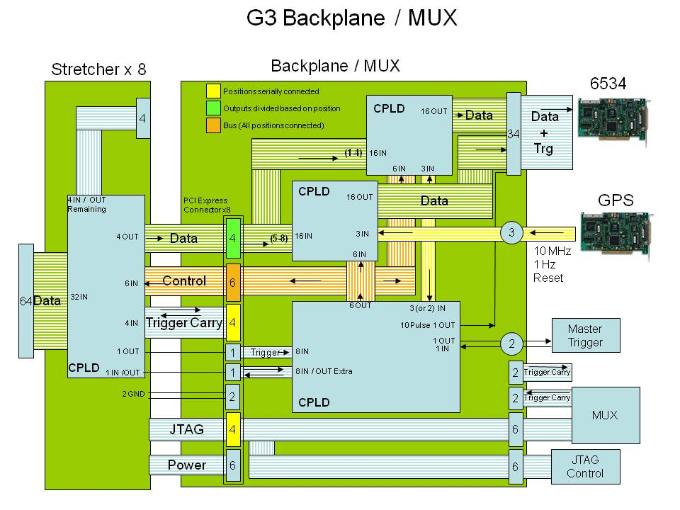 Figure 8. A schematic of the custom front end electronics consisting of 8 Pulse Stretcher boards and one Multiplexer backplane card. ** need to explain some of the details in the caption or text – like JTAG, MUX that isn’t the MUX board, JTAG control, etc….**

The DAQ timing sequence starts with the signal in the preamp. The signal which reaches the stretcher board may or may not produce a trigger, depending on the logic programmed in the CPLD. If conditions satisfy the trigger requirement, then the trigger bit triggers the start of read on the MUX board. The read begins with a 1.2 to 1.4 μs (6 or 7 clock cycles of the 5MHz clock) delay to wait for any signals which might have had longer drift time. After this delay the read controller starts the multiplexers switching ** better way to say this?? ** and causes the 6534 card to read twelve times: , 8 (how many bit?? 32-bit?) words from the pulse stretchers and 4 ??-bit words from the stretcher info ** better name** what is in the info?** line, the count value on the two counters, and finally the error checking line. For the entire 12 clock cycles of the data read (2.4 μs) the data is latched in the stretchers to ensure that the signals are live for the duration of the read cycle and to prevent noise or another later signal contaminating the event. The timing of the DAQ is summarized in figure 9. The entire read cycle extends two clock cycles past the end of the data read and is ** enveloped by a non-retriggable window.** what does that mean! is there a busy signal? Can you explain it that way? ** This window lasts 4.0 to 4.2 μs from the trigger to the time another trigger can activate another read. The Busy state ?? lasts this long in order to allow for the possibility of the trigger still being high after the end of the read because of the drift time delayed signals. *** hmmm – can’t we crowbar the trigger back down rather than wait this long !!!** This window gives a maximum data rate for the DAQ to be 238 KHz which is far above the faster data rate that can be achieved under normal operation of full multiplexer containing 256 data channels (8 stretchers with 32 channels each) ** *I don’t understand the previous sentence *** . Because of the 4 μs stretch in the signals in the pulse stretcher, it is not possible to cycle the trigger faster than 250 KHz at an absolute maximum.

** what is missing is a data dump or something so you know what the bits in each word mean *** Could be done by example or figure?**
Figure 9. ** need darker picture**Timing diagram for the DAQ. Here Channel 1 and 2 represent two channels on a pulse stretcher from a particle passing through both tube layers. The difference in their timing is a drift time difference.
With each multiplexer board able to accommodate 8 pulse stretchers and each computer able to hold two NI 6534 cards (each which can handle only one multiplexer), we are able to accommodate a total of sixteen 64 pin signal cables per computer. In total, five computer stations read out the entire veto shield, distributed in four geographical locations. The data from the five individual computers is sent to a central data server available to LBCF users.
Software Tools and Trigger Configuration
The data is read from the NI 6534 card into the computer using a LabView program, with the graphical interface shown in figure 10. This program is set up to read the data in and reconstructs tube hits before saving the data to a file. The reconstruction is necessary because the first phase of multiplexing causes the data to be mixed in an unintuitive way. Once the data is reconstructed, it can be saved directly to file or stored in a database for later use. Beyond simply recording the data, the DAQ software also checks for errors, such as a 6534 buffer overflow or the timer getting out of sync. The read can then be reset. Although these problems are extremely rare, they can stop data-taking is they are not immediately detected and recovery initiated.
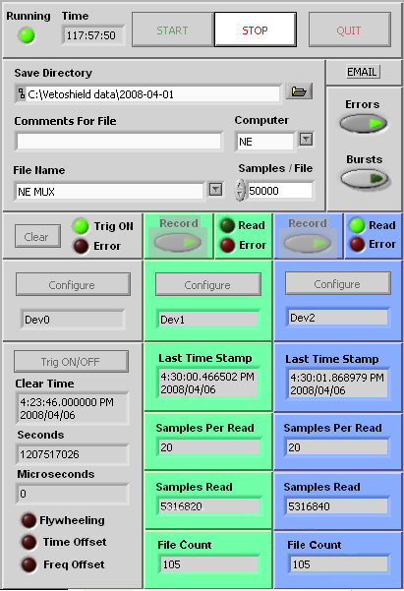
Figure 10. Virtual instrument panel for the LabView program which reads out the veto shield.
There is also a diagnostic program which simply displays the data directly on screen and bypasses writing it to file. This allows us to get real time responses for testing the DAQ and the tubes themselves. This program can display either the direct binary representation of the data or operate in a scalar counting mode, displaying the number of hits received on each data channel over a specified period of time. The scalar count mode can be displayed in chart form to compare the channel performance. ** picture of some output? Next to fig 10?** A second diagnostic program tests the DAQ performance. This program uses a 32 channel switch box to produce simulated preamp pulses and can sweep through any combination of channels to ensure that the data is being displayed in the correct places and that the triggers are being formed correctly.

We have created two databases (what format?) to keep track of the tubes: the first locates the tubes to several cm precision using a survey data and a second is a reconfigurable map of the tube to cable to electronics board. **** More on the database, including how it talks to the GUI. Plus information on the GUI etc. how does this “talk” to the monte carlo geometry? Refer to the figure below which shows 2 muon events using the GUI, as illustration, so the same figure will do double duty. ***

The muon trigger logic for the veto shield is based on the coincidence of two layers. Due to the overlapping tube geometry of each module and the way nested modules form a wall panel, a muon trigger can be formed by the coincidence of layers between adjacent tubes, as well as in the same tube. This triggering scheme is illustrated in figure 11. With this triggering scheme we are able to trigger on muons entering the shielded cavern at any angle or location and reject events that are clearly not muons. This scheme is implemented inside the CPLDs on the pulse stretcher boards. There are interconnects between stretcher boards which continue the trigger between the last channels of one stretcher and the first of the next. Other triggers which we have found useful are a simple singles trigger which reads out all events. This can be a good diagnostic tool to understand whether tubes are dead or noisy **– good place to talk about the singles rate? **

You wrote ** it may be required that two layers of tubes have muon hits at the same time *** what does that mean – it can’t trigger if they are not at same time? *** A board can be left without trigger logic and simply be used to read data in a slave mode as well.
Figure 11. *** darker picture ** This is an illustration of our primary trigger logic implemented for three tubes. The three possible path types that can cause a trigger are shown in red. The logic implementation is also shown for this three tube system. The carry in and carry out bits allow the logic to be linked between pulse stretchers to account for tracks that intersect two modules read out by different stretcher boards.
The MUX board and stretcher boards can also send and receive external triggers. Each of the ten MUX boards required to operate the veto shield has its external trigger in/out connected to a central trigger control box. This box contains two CPLDs, one each to control the input and output triggers plus a number of trigger in/out lines which can be used by users to either receive a veto pulse from the shield or to send out a trigger to cause the shield to read. Since the shield is spread over ten MUX boards and these boards are each matched to a geographic region of the shield, the CPLDs can be programmed to give a localized trigger to meet user needs. If this simple partition of the shield is not sufficient, then a user can obtain access to the trigger coming from a single pulse stretcher via the duplicate trigger output spigot. This system gives a flexible user oriented system which should be able to deal with the changing environment of the LBCF.

Veto Efficiency Tests and Energy Calibration (can we get some of Kyle’s work? Where is the NOTEBOOK!!)

Angular Distribution and Flux of incoming Muons

Monte Carlo Results for Muons

How to use this to benchmark Neutrons
NMM and time-stamping (prototype data matching between shield and NMM)
MC on neutrons in tubes
MC on high multiplicity events
Data matching to MC on high multiplicity events.

