Facility for Assay and Acquisition of Radiopure Materials

Priscilla Cushman – September 2, 2009

12 month Milestones | 24 month Milestones | 36 month Milestones
Collate previous measurements, (radon variations, neutron and gamma fluxes and rock radioisotope information)  Prepare site characterization database and begin targeted measurements.  Setup site-specific n,γ GEANT4 MC of water shield and rock  (SD and UM)  Study immersion tank parameters  Optical properties, H2O and LS purity (BHSU)  Determine experimental needs and sensitivities of S4 groups as well as possible synergies from outside physics | Characterize site: Measure radon, n,γ at all accessible levels  Host ILIAS measurement team and cross correlate with their measurements  Determine minimum acceptable radon levels for screening, storage, and experiments.  Optimize external water shield thickness, radiopurity of structural members (SD and UM)  Define immersion tank properties decide between H2O and LS, active vs passive, size and number of ports  Decide on number, type and sensitivity of screeners to be located inside the FAARM  Preliminary simulations of backgrounds for beta screening.  Define type and amount of additional shielding needed for individual screeners based on simulations and requirements  Determine footprint of auxiliary services, such as a clean machine shop, material storage, the water purification plant, sample preparation and wet chemistry labs | Finish site characterization  Establish joint backgrounds working group with new European infrastructures organization.  Conceptual plan for radon mitigation  Conceptual design of the surrounding water shield  Conceptual design of the ultra-sensitive immersion tank  Determine placement of the alpha, beta, and gamma screeners within the FAARM  Finish simulations of backgrounds for beta screening  Design of additional shielding configurations for screeners based on the sensitivities required for each screener.  Conceptual design of the FAARM infrastructure
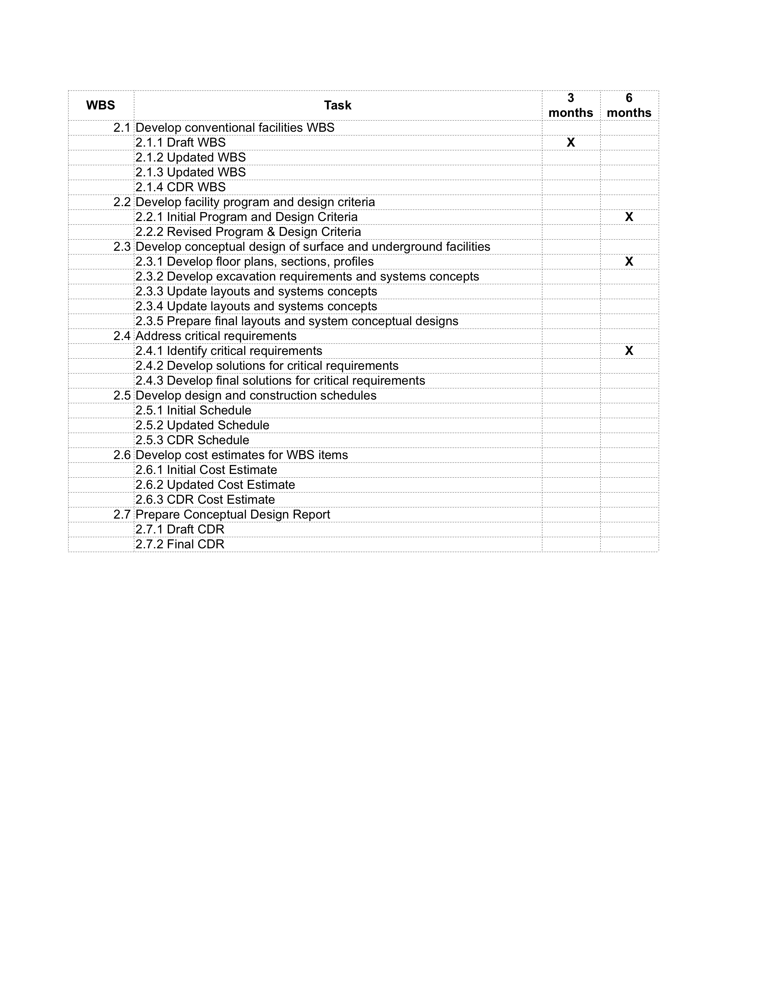
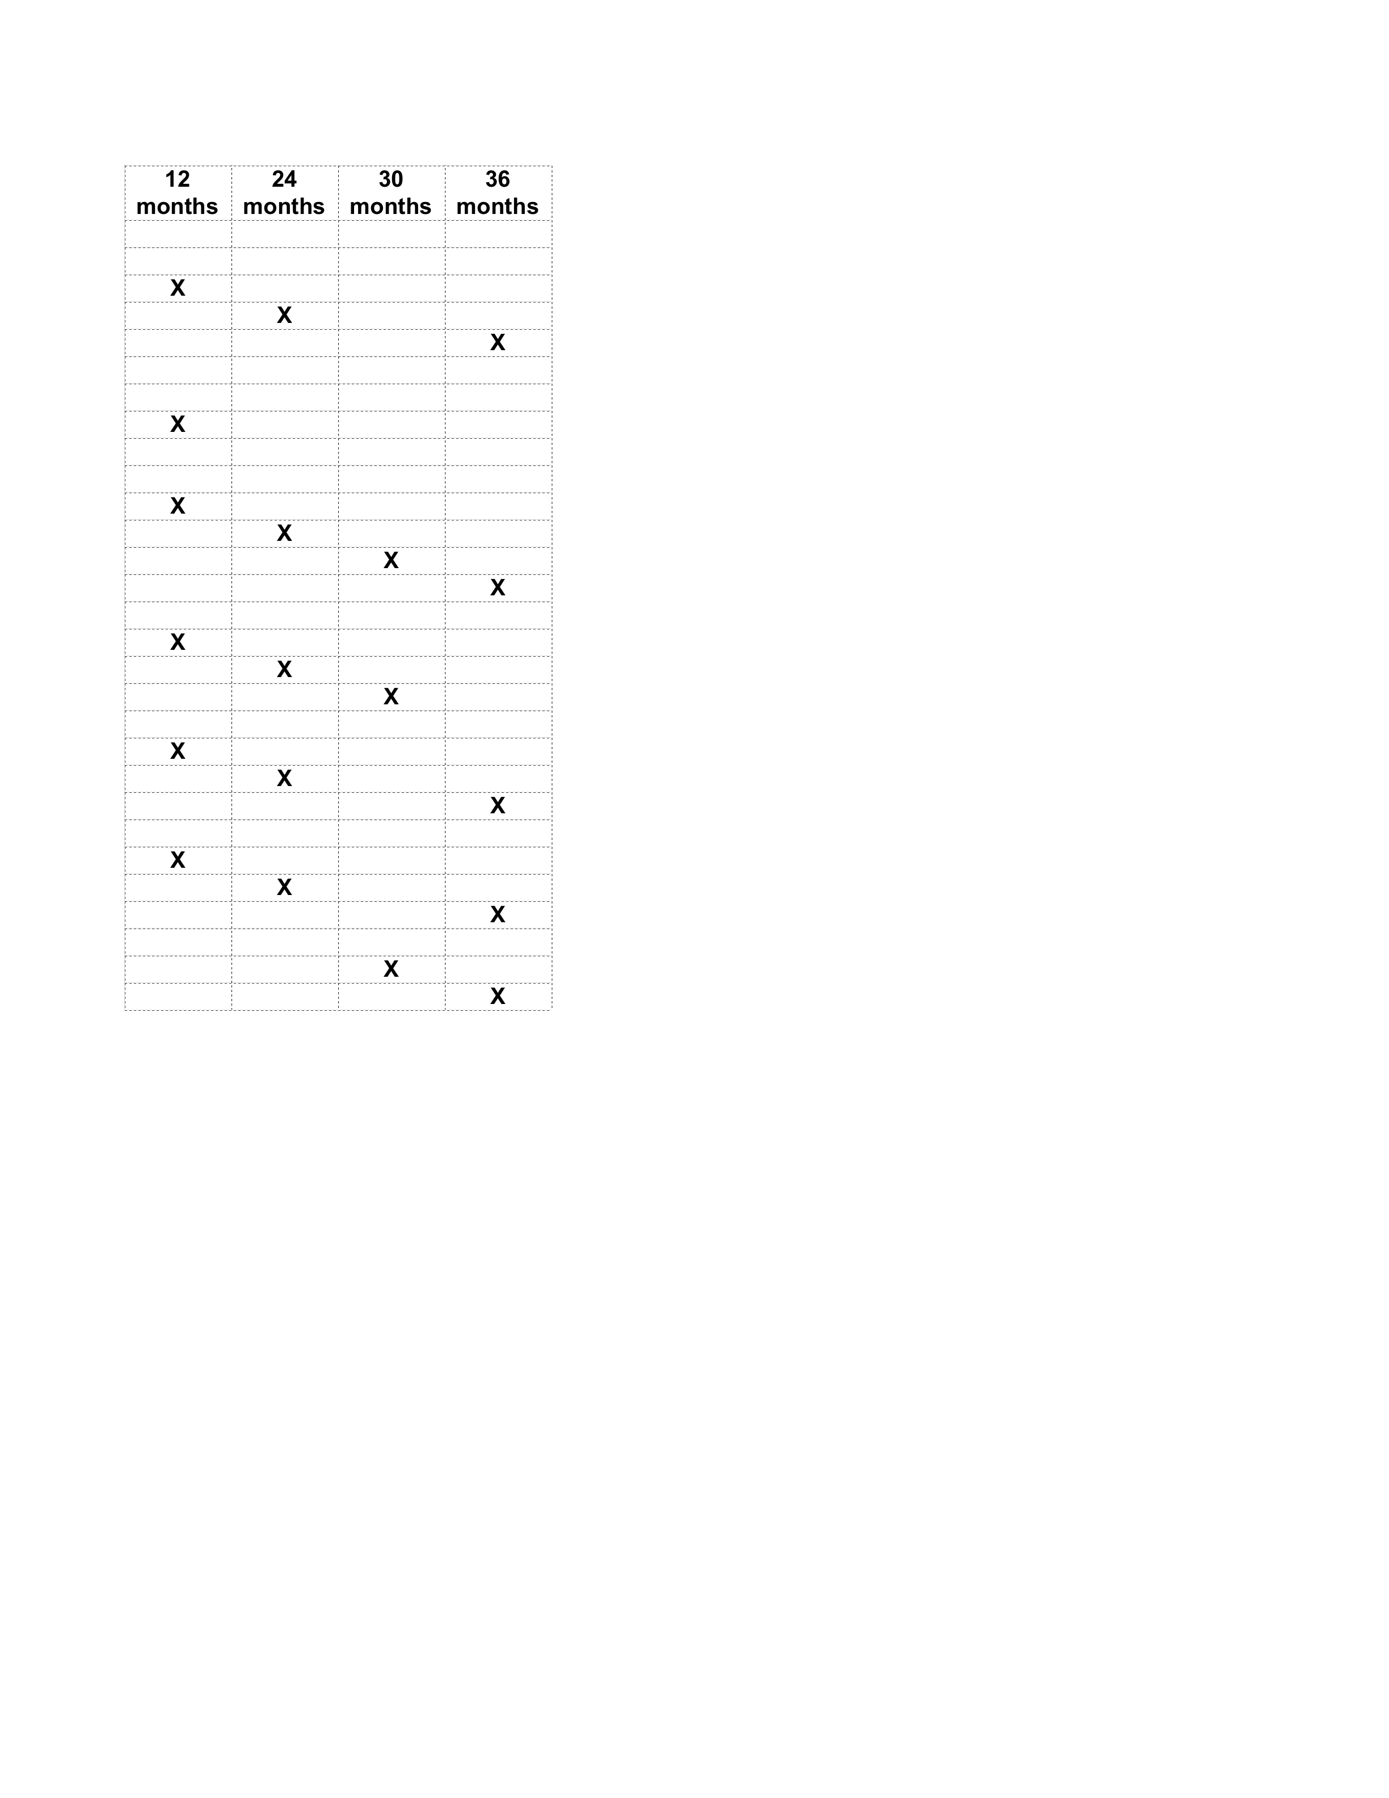
Specific Milestones Related to CNA Engineering task WBS 2.0

